CURRENT STATUS OF THE PRESENCE/LACK AND CONTENT OF GENDER EDUCATION IN EU MILITARY ACADEMIES – TRENDS AND EXPECTATIONS

Assoc. Prof. PhD Nevena ATANASOVA-KRASTEVA

Abstract: The scientific paper presents the results of the conducted survey of the presence or lack and the content of the gender equality education in the European military academies and universities.
Keywords: EU military basic education, gender equality policies, implementation, actual status.

The gender equality implementation as a topic has gained increasing importance in recent years, both within the European Union and NATO, and in the broader context of security and defence.
Gender equality can no longer be considered solely a matter of social justice and equal opportunities. It has become an important factor in organizational effectiveness, the quality of leadership, institutional resilience, and the ability of security and defence organisations to respond effectively to the complex challenges of today.
In this context, military academies and institutions of military education have a particularly important role to play. They are responsible not only for developing the professional knowledge and competencies of future officers, but also for shaping the values, attitudes and leadership approaches that will influence their future professional practice.
As stated in one of the conclusions of the European Union Military Staff’s document on the Training Requirements Analysis Report on Gender EU Military Training Discipline: “Most of EU MS train their military personnel in Gender Mainstreaming during the educational stage. It is also very common that MS train their military personnel in Gender during generic basic and pre-deployment training prior to joining UN, NATO or CSDP missions and operations.” [1]
Another contemporary publication specifically examines the relationship between gender equality, military education, institutional culture, professional military education, and operational effectiveness. The authors Ceyda Kuloğlu and Murat Koçanli point out that gender perspectives often remain peripheral or are absent from curricula, training scenarios, and institutional culture, despite international commitments regarding WPS. [4]
Therefore, the question before us is not simply whether gender equality policies have been formally adopted, but to what extent these principles are effectively integrated into the education, training and professional culture of future military leaders.
For the purposes of this report, it would be useful to offer some definitions and share specific facts. In addition, let us seek the answer to the question of where do we stand today? The European Union has made significant progress in promoting gender equality. We now have a strong political, legal and institutional framework, supported by concrete measures and a new Gender Equality Strategy for 2026–2030. [2]
However, the current situation also shows that progress is uneven and that formal equality does not automatically lead to substantive equality.
The latest Gender Equality Index gives the European Union a score of 63.4 out of 100, with considerable differences between Member States. This tells us that gender equality is not yet a reality across Europe, but an ongoing process that requires sustained commitment and practical action. [3]
These and other data raise the logical question not only of what equality policies have been adopted, but rather of how these guiding documents and strategies are translated into educational policies, integrated into professional practice, and influence leadership styles and organizational culture.
Moreover, this is where military education becomes particularly important. Military academies are not only institutions for acquiring professional knowledge and skills. They are also environments in which future leaders develop their values, attitudes and understanding of leadership and responsibility.
If we want gender equality to become an integral part of European security and defence, we need to ensure that it is also an integral part of the education and preparation of future military leaders.
In this context, a misunderstanding or misinterpretation of the term "gender education" continues to be observed in modern educational models, including military education.
According to UNESCO publications “Gender education refers to the teaching and learning processes that promote understanding of gender identities, roles and equality. It aims to address issues related to gender discrimination and empower individuals with knowledge about their rights and responsibilities.” [7].
When we start discussing the implementation of these policies it means that the implementing gender policies in education requires clear frameworks, teacher training, and inclusive daily practices. [5].
Аnd when we move the discussion to the Armed Forces we must understand that “implementing gender policies in the Army requires structured education, institutional training, and a clear framework based on international standards like the UN Women, Peace, and Security agenda.” [6].
In recent years, interest in examining the current state of gender-related training specifically its inclusion and content within European military academies and universities has intensified, driven by the growing demand for a diverse range of skills among future military leaders. In this context, the “European Initiative for the Exchange of Young Officers, inspired by Erasmus+” established "Line of Development 10 – Gender mainstreaming” back in 2018. Experts and academic representatives from the European military academies are actively working to promote the integration of gender equality training into curricula and educational programs, in alignment with national strategies and legislation. To ensure the training offers relevant and appropriate content, the members of the Initiative hold regular meetings and training sessions, organize annual seminars, and participate in international projects under the umbrella of the so-called "Military Erasmus."
In 2026, a seminar was organized on a topic “Current state of gender equality implementation in EU - challenges and perspectives for the gender education in the European military academies” that prompted the conduct of a study with the aim of showing not only whether gender equality is officially recognized, but also whether it is reflected in curricula, staff capacity, teaching practice, operationally relevant training and European cooperation. The analysis distinguishes policy commitment from educational implementation, as the existence of an institutional policy does not indicate that cadets acquire measurable competences.
The questionnaire was designed by the chair of Line of Development10 and comprises several sections:
- descriptive data - institutional profile;
- current status;
- evaluation questions, grouped into 6 dimensions, which are assessed on a 5-point Likert scale:
- Institutional policy;
- Integration into curricula;
- Teacher competence;
- Learning resources;
- Perceived effectiveness;
- Future development.
- current practices;
-open questions.
The survey was conducted online, with the questionnaire sent to representatives and experts from European military academies that are members of the "Military Erasmus" Initiative. The results obtained were presented and analyzed during the annual Gender Erasmus Seminar held at the Royal Military Academy in Brussels, Belgium (https://www.emilyo.eu/lod-10-gender-mainstreaming).
This report presents a portion of the obtained results and the associated analyses based on the large volume of data provided. All responses from the conducted survey, along with in-depth statistical analyses and conclusions, will be the subject of future publications.
The dataset contains 27 completed questionnaires and 45 variables. Responses were collected between 5 August and 3 September 2026. (fig. 1)
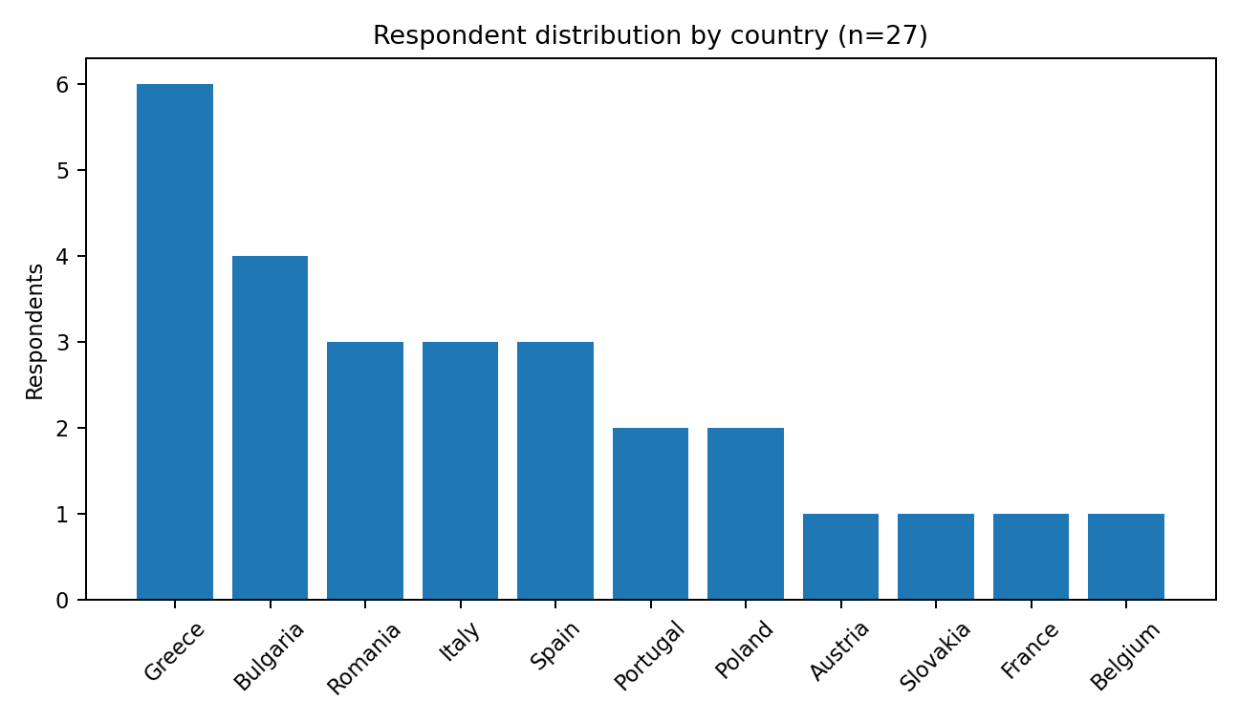
Fig.1 Profile of respondents and participating contexts

Responses cover 11 ЕU countries shown in figure 1. Greece contributes six responses; Bulgaria four; Romania, Italy and Spain three each; Portugal and Poland two each; Austria, Slovakia, France and Belgium one each. The sample therefore offers useful cross-European diversity but is not nationally balanced. It should be noted that some countries such as Austria and Belgium have only a single military educational institution. This implies that even if survey responses were not received from every military academy in Europe, data analysis remains possible without compromising the final findings.
The next question in the questionnaire provides information regarding the respondents' positions. Respondents occupy roles with direct visibility over education and institutional policy. Twelve identify as lecturers/academic staff, four as programme coordinators, two as vice-rectors, and the remainder include faculty members, administrative staff, a gender/equality specialist and senior training or management positions. This role diversity strengthens the interpretive range of the dataset, while introducing diversity of perspective.
Figure 2 presents the summarized results regarding the current state of training on gender equality in the European military academies participating in the study. 15 respondents (55.6%) report full provision of education or training related to gender equality policies; 7 (25.9%) report partial provision; and 5 (18.5%) report no provision. Thus, 22 of 27 responses (81.5%) indicate at least some educational engagement.
55,6 %
18,5 %
25,9 %
Fig. 2 Current state of gender equality education in
the EU military academies.

The important distinction, however, is between presence and depth: delivery ranges from mandatory provision and stand-alone modules to content included in other courses, elective formats and extracurricular activity. (fig.3)

Fig. 3 Answers of the question: “If your institution offers training or preparation related to gender equality policies, in what form is it organized?”

From the responses of the 22 academies that offer such training, it is observed that in 5 of them the training is mandatory as a separate subject, while in the remaining institutions combinations of its inclusion as part of another academic discipline and/or as an elective and extracurricular form of training are observed.
Another issue concerns the strategies, policies, and frameworks regarding equality that are incorporated into the educational process. The responses show a broad normative base, which is visible on table 1. Human rights, prevention of discrimination, sexual harassment and abuse, diversity and inclusion, the EU Gender Equality Strategy, the Women, Peace and Security Agenda/UNSCR 1325, NATO gender policy and conflict-related gender violence all appear in the reported curricula. The pattern indicates that gender education is frequently situated at the intersection of legal/ethical compliance, leadership, protection, inclusion and operational security.

Table. 1 Gender Policy frameworks represented in
the military education

Framework / thematic area | Number of selected answers | % of respondents
Prevention of discrimination | 21 | 77.8%
Human Rights | 20 | 74.1%
Sexual harassment and abuse | 16 | 59.3%
Diversity and Inclusion | 16 | 59.3%
EU Gender Equality Strategy | 15 | 55.6%
Women | 14 | 51.9%
Peace and Security Agenda (UNSCR 1325) | 14 | 51.9%
NATO Policy on Gender Perspectives | 14 | 51.9%
Prevention of Conflict related gender violence | 11 | 40.7%

Another interesting observation reveals that 37% of the academies participating in the survey have included in their education all documents and strategies related to human rights, equality policies and their implementation in the EU and NATO. Another 22% of the academies offer partial inclusion of the regulatory framework, and in 19% the training includes only NATO and EU strategies and human rights legal frameworks.
Some practical questions are proposed in the final part of the study. An answer of the question „Approximately how many teaching hours are dedicated annually to gender equality topics?“ is shown. (fig.4)
Teaching intensity remains limited in much of the sample. 12 respondents (44,4%) report only 1–5 hours annually; 7 (25.9%) report 6–10 hours; 4 (14.8%) report 11–20 hours; and only 3 (11.1%) report more than 20 hours and 1 (3,7 %) gives negative answer. This distribution suggests that formal recognition often exceeds curricular volume.
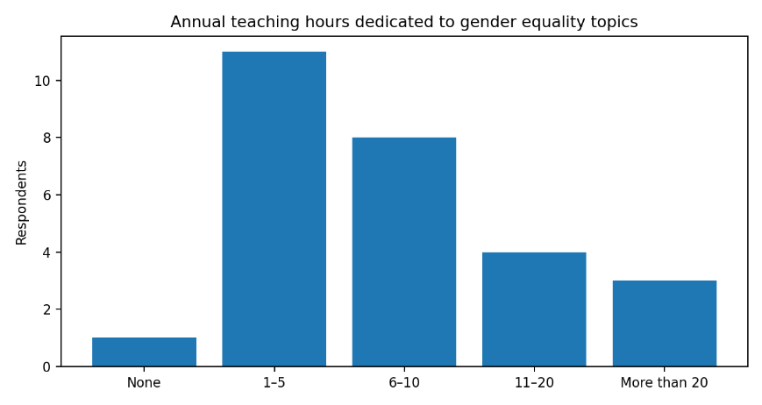
Fig. 4 Teaching hours for gender education

The results show a strong concentration in the relatively low annual number of hours. The largest group – 44.4% of respondents – indicates between 1 and 5 hours of training per year. The group with 6–10 hours – 25.9%, follows this.
Therefore, 70.4% of all respondents indicate between 1 and 10 hours per year for training on gender equality topics.
More training that is intensive is found in a smaller part of the surveyed group: 14.8% indicate between 11 and 20 hours, and 11.1% – more than 20 hours per year. In total, 25.9% of respondents report more than 10 hours of training per year.
The results therefore support the conclusion of significant institutional variability in the intensity of training. The topic is included in almost all the educational settings represented, but its quantitative scope varies significantly – from minimal presence to more than 20 hours per year. This is an important argument in favor of developing a common minimum educational framework that would define not only the content and learning outcomes, but also a recommended minimum volume of training.
Is learning assessed? It is also an important information regarding on measuring the results of the gender training provided and that is why this question is included in the survey.
Learning assessment is reported as “Yes” by 19 respondents (70.4%), “No” by 8 (29.6%), with the remainder reporting uncertainty or conditional arrangements. (table 2)

Learning assessed | Answers | Distribution in %
Yes | 19 | 70,4 %
No | 8 | 29,6 %

The results show that for 70.4% of respondents, some form of assessment accompanies training. This is a clear majority and indicates that in a significant part of the presented educational practices, the topic is not limited to providing educational content, but also includes a mechanism for checking the acquisition.
At the same time, the result that for 29.6%, training is not assessed is significant. Practically, almost three out of every ten respondents indicate the absence of assessment.
This result is even more significant when compared with the analysis of data from the Likert scale which analysis is not included in the present report. The finding from the Likert analysis is cited solely for comparison - in that analysis, respondents rated the training’s impact on awareness, leadership skills, preparedness for multinational operations, and the prevention of discrimination positively. However, given that nearly 30% of the training sessions did not include an assessment component, some of these reported results would be difficult to verify through formalized indicators of acquired competencies.
The final section of the study presents open-ended questions addressing the challenges associated with implementing training on gender equality policies.
The responses reveal four interconnected groups of challenges, which have been subjected to qualitative analysis. These should not be viewed as mutually exclusive categories, as many responses combine constraints related to culture, training content, and capacity. These 4 clusters are:
  - Curriculum integration, time and operational relevance.
The first cluster concerns curricular congestion and relevance. Respondents report difficulty finding time and resources in already demanding military programmes, integrating material across diverse branches and specialisations, and connecting gender education to core military/naval training. The implication is clear: adding stand-alone theory without operational contextualization is unlikely to produce durable integration.
  - Institutional culture, stereotypes and resistance.
Respondents describe traditional gender stereotypes, masculine institutional norms, skepticism, underestimation of the topic and resistance from different organizational levels. Several responses indicate that the challenge is not formal opposition to equality but the perception that gender is secondary to “real” military education or primarily a women’s issue. This is a classic implementation barrier: formal policy can coexist with weak professional ownership.
  - Sustaining institutional commitment and translating awareness into practice.
Several responses move beyond awareness and identify the deeper problem of institutional sustainability: maintaining engagement, ensuring senior-level support and translating classroom discussion into everyday organizational behaviour. This distinction is essential for project design because awareness is an intermediate outcome, not the endpoint.
  - Staff competence, awareness and professional development.
Staff awareness, subject-matter expertise and regular updating emerge as enabling conditions. Where instructors are not confident in the operational rationale or lack appropriate teaching resources, implementation becomes dependent on isolated enthusiasts. This creates fragility and limits institutional scale.
To summarize, an interpretation of the strongest and weakest signals obtained from the study is presented. This also includes conclusions drawn from the analysis of responses to the section of the questionnaire featuring statements rated on a Likert scale. (fig.5)
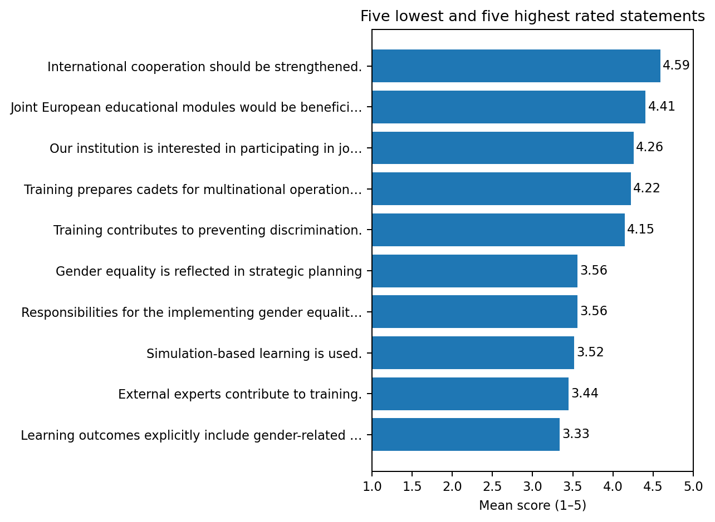
Fig. 5 The strongest and weakest signals obtained from the study

Interpretation of the strongest signals.
Three future-oriented items stand out: international cooperation should be strengthened (M=4.59), joint European educational modules would be beneficial (M=4.41), and institutions are interested in joint initiatives (M=4.26). This is not merely a positive attitude toward networking. In combination with reported differences in curricular hours, delivery formats and staff development, it identifies a concrete coordination problem that a European network like EMILYO can address through common learning outcomes, common modules and shared faculty capacity and good practices.
Among current educational outcomes, preparation for multinational operations is rated highest (M=4.22), followed by support for ethical and inclusive leadership and prevention of discrimination (both M=4.15 and M=4.15). These findings are strategically important because they position gender education within core military professional competence rather than as a random social-policy subject.

Interpretation of the weakest signals.
The weakest current-state item is the explicit inclusion of gender-related competencies in learning outcomes (M=3.33). These points to a quality-assurance gap: content may be present without being translated into assessable competencies. External expert contribution (M=3.44) and simulation-based learning (M=3.52) are also comparatively weak. Strategic planning and clearly assigned implementation responsibilities each score 3.56 and 3.56, respectively. Taken together, these results suggest that institutionalisation is incomplete at the points where governance, curriculum design, pedagogy and assessment must connect.
In conclusion, the study outlines a picture of European higher military education in which the normative legitimacy of gender equality education and the integration of a gender perspective are firmly established, yet their practical implementation varies. Respondents generally report the presence of institutional support, equal opportunity policies, and the educational value of the subject. They also recognize significant benefits for multinational operations, ethical leadership, and the prevention of discrimination and gender-based violence. This provides important evidence of the need for training on equality policies, which in turn influence the leadership competencies of the future officers.
The main weaknesses lie in the process of translating policies into an educational structure: clearly defined competencies, the allocation of curriculum responsibilities, lecturers’ training, the practical focus of the training, the involvement of external experts, and systematic evaluation. Qualitative data confirm that traditional stereotypes, institutional culture, heavy curricula, and varying levels of commitment from the professional community continue to hinder implementation.
These are not arguments against gender-related training; rather, they define the conditions under which such education must be developed to ensure it is operationally sound and institutionally sustainable.

Bibliography:

1. Council of the European Union, Official document of the European External Action Service of 21/02/2020, European Union Military Staff, EEAS(2019) 1115 REV 6.
2. European Commission, Gender equality strategy, https://commission.europa.eu/strategy-and-policy/policies/justice-and-fundamental-rights/gender-equality/gender-equality-strategy_en?utm_source=chatgpt.com [viewed 2026-09-05].
3. European Commission, Gender Equality Index, https://eige.europa.eu/gender-equality-index/2025 [viewed 2026-09-05].
4. Kuloğlu, C., & Koçanli, M. (2025). Gender Equality in AI-Supported Military Education: Literature Insights and Evidence from Turkish Institutions. Journal on Baltic Security, Volume 11, Issue 2 (2025), pp. 124–156, https://journalonbalticsecurity.com/journal/JOBS/article/139/read?utm_source=chatgpt.com [viewed 2026-09-14].
5. Otieno-Omutoko, L., Mwaura, P., Governance and Transformations of Universities in Africa: A Global Perspective, Chapter 12: Gender Policy as a Management Strategy in Education, Emerald Publishing Limited, 2014
6. PfPC SSRWG and EDWG, Handbook on Teaching Gender in the Military, Geneva, DCAF and PfPC, 2016
7. UNESCO, Gender equality in education, https://www.unesco.org/en/query-list/g/gender-equality-education [viewed 2026-09-05].

Associate Professor, PhD Nevena Tsvetkova Atanasova- Krasteva
Vasil Levski National Military University
Veliko Tarnovo
“Bulgaria” blvd. 76
nzatanasova@nvu.bg

