DESIGN AND IMPLEMENTATION OF A REAL-TIME CSS MODEM ON SOFTWARE-DEFINED RADIO

Ivan P. Ivanov

Abstract: The design, implementation and measurement of a real-time modem with chirp spread spectrum (CSS) modulation on a software-defined radio (SDR) platform are presented. The symbol, the frame, the synchronization and the decision rule are derived from the initial requirements. The receiver acquires the frame in the stream and decodes it at its rate. Packet error rate (PER) and sensitivity were obtained experimentally over the air and over cable with USRP frontends.

Key words: CSS modem; frame synchronization; carrier frequency offset; real-time reception; software-defined radio

I. INTRODUCTION
The national security system rests on its communication and information systems, and within them radio communication is the part that admits movement [9]. Spread spectrum with linearly frequency-modulated symbols (chirp spread spectrum, CSS) is the physical layer of the most widespread low-power wide-area link: the symbol lasts long, its energy is collected into a single frequency bin, and the decision remains possible at a negative signal-to-noise ratio [15]. The waveform is set out in [5], the protocol above it in [11], the limits of the network in [1], [3], the place of the link among the technologies for wireless sensor networks in [8], and one of the field nodes it serves in [13]. The difficulty is not demodulation but synchronization.
What is published describes separate parts: software decoders on open platforms [10], [14]; the algorithms for demodulation and synchronization [6], where the offset is absorbed into the timing synchronization; an open reference design following the deployed physical layer, with blocks for both offsets [17]; and a survey of the alternative waveforms [4]. A complete transceiver on an open platform with measurements has been shown for the related direct sequence spread spectrum (DSSS) [18], but it follows a deployed standard layer. A description of the design of a complete modem — from the initial requirements to the measured finished chain — is not to be found.
The contribution of this report is such a description: a real-time CSS modem on software-defined radio, whose receiver acquires the frame on its own in the stream and decodes it at the rate of that stream. The initial requirements are set out, together with the symbol and the frame derived from them, the stages of synchronization and the decision rule; the characteristics are measured over the link. The profile is a baseline, deliberately without error correction, and serves as a reference point on the same equipment and in the same setting.

II. SYSTEM MODEL OF A CSS MODEM

A. Software-defined radio and hardware block diagram
Software-defined radio (SDR), introduced as an architectural principle by Mitola [12], performs the digital processing in software on a general-purpose device, and reduces the fixed part of the radio to conversion between analogue and digital and to frequency translation [7]. That boundary — computing device against radio-frequency front end — is shown in Fig. 1.
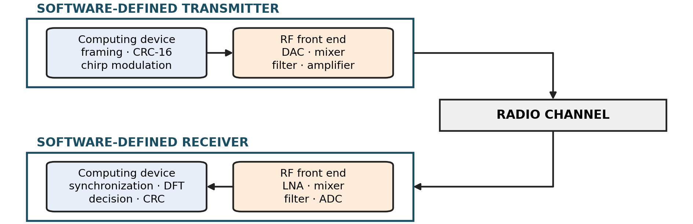
Fig. 1. Hardware block diagram of an SDR transceiver
The consequence is that the spreading factor, the frame and the synchronization are changed without touching the equipment, while the difference between the reference oscillators remains a property of the link — precisely the object of the measurement in Section IV. Thanks to this architecture, a multitude of functional solutions are realized on one and the same platform.

B. Functional block diagram
The chain of the modem — from the source to the recovered bits — is given in Fig. 2. In the transmitter the stream is divided into frames, a check word is appended to each, the bits are scrambled with a known sequence and labelled with a Gray code; the label selects the cyclic shift of the linearly frequency-modulated symbol. Ahead of the payload stand a preamble of up-chirp symbols and a delimiter of down-chirps, and finally the frame is normalized by its root-mean-square value.
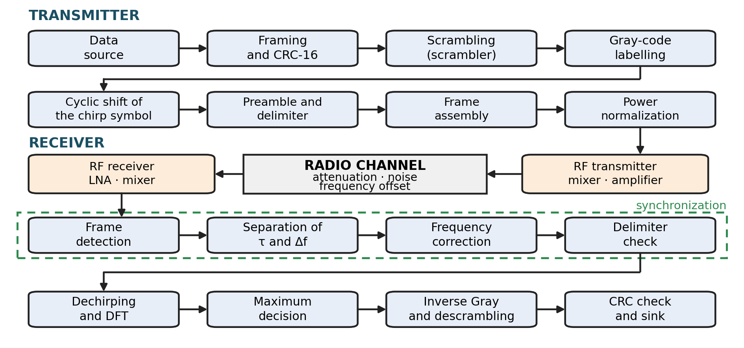
Fig. 2. Functional block diagram of a system with CSS modulation
In the receiver the processing runs in the reverse order, but with an addition: with no external information about arrival or offset, the first four stages are the synchronization, and only after them does demodulation begin.

C. Mathematical description
Let $SF$ be the spreading factor, $M=2^{SF}$ the size of the symbol alphabet, $B$ the occupied bandwidth, and $f_{s}=OSR⋅B$ the sampling rate at an integer oversampling ratio $OSR$. The symbol contains $N=OSR⋅M$ samples and lasts $T_{s}=M/B$. The base up-chirp symbol is a linearly frequency-modulated signal centred on zero frequency:
$$c[n]=e^{ jπ[B/{T_{s}}t^{2}-Bt]}, t=\frac{n}{f_{s}}, n=0,…,N-1,$$ | (1)
that is, its instantaneous frequency rises linearly from $-B/2$ to $+B/2$. The symbol with index $m$ is a cyclic shift of the base symbol, $s_{m}[n]=c[\left(n+m OSR\right) mod N]$; because the shift is cyclic, the occupied bandwidth does not grow with $m$ — measured over the assembled frame, 99 % of the power is collected in 130 kHz at $B=125$ kHz.
The received signal carries a delay $τ$ in samples, a frequency offset $Δf$, an unknown initial phase $φ$ and additive white Gaussian noise $w[n]$ with two-sided spectral density $N_{0}$:
$$r[n]=A s_{m}[n-τ] e^{ j(2πΔf n/f_{s}+φ)}+w[n].$$ | (2)
The receiver multiplies the symbol window by the complex conjugate of the base symbol — dechirping — and transforms it by Fourier:
$$Z[k]=\sum_{n=0}^{N-1}{r}[n]c^{*}[n]e^{-j2πkn/N}.$$ | (3)
At $τ=0$ and $Δf=0$ the quadratic phase is removed, a tone of frequency $m Δf_{b}$ remains, where $Δf_{b}=B/M=f_{s}/N$ is the width of the frequency bin, and the maximum falls exactly at $k=m$.
The decision rule, however, is not the maximum of $∣Z[k]∣$. The symbol with index $m$ is a cyclic shift of the base symbol in time by $m OSR$ samples, and the oversampling makes that shift larger than one sample. The decision is therefore matched filtering over all $M$ candidates:
$$\hat{m}=arg\max_{m}∣\sum_{n=0}^{N-1}{r}[n] s_{m}^{*}[n]∣^{2}.$$ | (4)
Since the candidates are cyclic shifts of one and the same symbol, all $M$ correlations are computed with two Fourier transforms, $F^{-1}\{R⋅C^{*}\}$, read at the lags $-m OSR mod N$.
The decision is non-coherent — the initial phase $φ$ is unknown and is discarded by taking the magnitude. For $M$ orthogonal equal-energy signals the probability of symbol error at $γ=E_{s}/N_{0}$ is
$$P_{s}=1-\int_{0}^{∞}{e^{-(u+γ)}}I_{0}​\left(2\sqrt{γu}\right){\left(1-e^{-u}\right)}^{M-1} du,$$ | (5)
where $I_{0}$ is the modified Bessel function of order zero. The frame fails at the first erroneous symbol decision, so with $N_{p}$ payload symbols $PER=1-{\left(1-P_{s}\right)}^{N_{p}}$ [2]. This is the bound against which the measurements of Section IV are referred.
The whole energy of the long symbol is thus collected into one bin — a spreading gain of $10lgM$ at the price of a low rate, $SF⋅B/M$ bits per second. More importantly, when only up-chirp symbols are processed the measured bin is $k_{↑}=Δf/Δf_{b}-τ/OSR$: the delay and the offset enter with the same sign and cannot be separated. It is therefore the synchronization, not the demodulation, that determines the structure of the receiver.

III. DESIGN OF THE MODEM
The initial requirements are collected in Table 1; the symbol, the frame and the stages of synchronization are derived from them.
Table 1. Initial requirements for the design of the modem
Requirement | Value
Role | framed transfer of a small payload between two independent nodes
Host | general-purpose computer and two SDR platforms
Reference oscillators | internal and independent; the offset between them is unknown
Receiver | acquires the frame on its own in the stream
Synchronization | timing and frequency offset are separated by construction
Data protection | one check word per frame; no error correction
Operating point | every frame decoded correctly over a laboratory link; frequency-estimate error below one percent of a bin
The profile is a baseline: it serves as the reference point against which the more advanced solutions of [4] are to be measured.

A. Symbol and grid
The spreading factor is the lowest of those in practical use, $SF=7$, because at that value the symbol is shortest and the errors of synchronization appear earliest; a conclusion drawn at $SF=7$ is conservative with respect to higher factors. The oversampling is eightfold, so that the Nyquist margin remains sufficient even at the largest admissible offset.
The grid that follows from it is collected in Table 2.
Table 2. Grid of the modem
Quantity | Value | Quantity | Value
Sampling rate | 1 MS/s | Samples per symbol | 1024
Occupied bandwidth | 125 kHz | Symbol duration | 1.024 ms
Spreading factor | 7 | Frequency bin width | 976.5625 Hz
Symbol alphabet | 128 values | Spreading gain | 21.07 dB
Oversampling ratio | 8 | Symbol rate | 976.5625 sym/s
The symbol stream carries $SF⋅B/M=6835.9$ bit/s — the upper bound, which the overhead fields and the gap between frames reduce.

B. Frame
The structure of the frame is shown in Fig. 3.
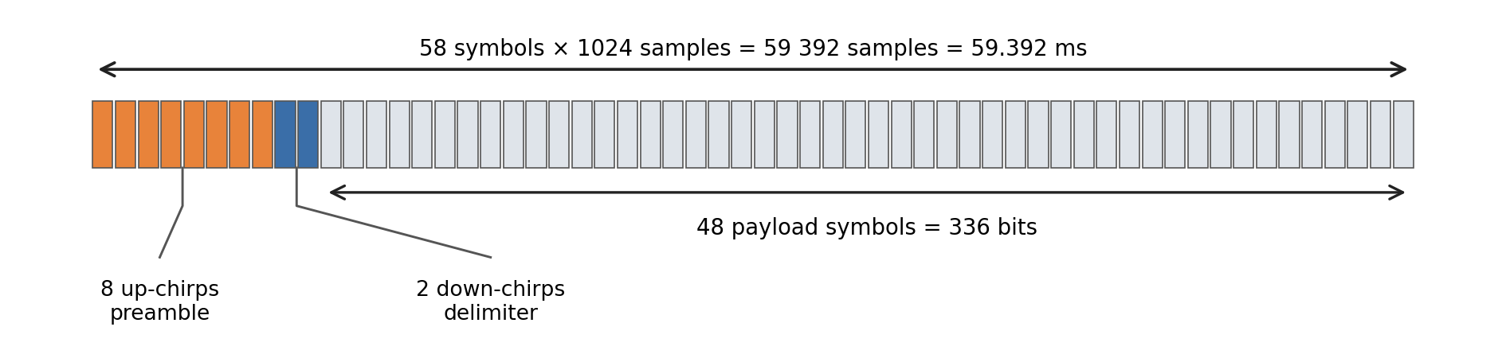
Fig. 3. Structure of the frame
The frame consists of 58 symbols: eight up-chirps with index zero for detection, two down-chirps as delimiter, and forty-eight payload symbols — 59 392 samples in all, that is 59.392 ms. The phase is continuous throughout the frame, including at the reversal of the chirp slope.
The payload is 336 bits, that is 42 bytes: forty bytes of data and a two-byte cyclic redundancy check (CRC) word, CRC-16 with polynomial 0x1021, over them. There are no overhead fields: the frame is of constant length and the profile is agreed off the air. With an interval of 4096 samples between frames the period is 63.488 ms, that is 15.75 frames per second, and the data amount to 5040 bit/s.
The two down-chirp symbols are not redundancy: without them the frame is decoded, but the offset is not measured. They are also an unambiguous delimiter, because a preamble of symbols with index zero is by itself indistinguishable from a symbol zero in the payload.

C. Frame detection
Detection works in the frequency domain and follows the criterion of [6]: a frame is declared when one and the same symbol index, or its nearest neighbours, is demodulated consecutively. The stream is cut into whole symbols; for the window beginning at sample $ν$, dechirping and the transform give
$$X_{ν}[k]=\sum_{n=0}^{N-1}{r}[ν+n] c^{*}[n] e^{-j2πkn/N},$$ | (6)
whence follow the index of the maximum and the measure of symbol presence:
$$b\left(ν\right)=arg\max_{k}∣X_{ν}[k]∣, μ\left(ν\right)=\frac{∣X_{ν}[b\left(ν\right)]∣}{\frac{1}{N}\sum_{k=0}^{N-1}{∣}X_{ν}[k]∣}.$$ | (7)
The measure is a ratio and does not depend on the level in the receive chain. A frame is declared when there exists a start $ν_{0}$ and a length $L≥L_{min}$ for which
$$μ\left(ν_{0}+iN\right)≥μ_{min} \text{and} ∣b\left(ν_{0}+iN\right)-b\left(ν_{0}\right)∣_{N}≤δ, i=0,…,L-1,$$ | (8)
where $∣⋅∣_{N}$ is distance modulo $N$. The working values are $L_{min}=6$ of the eight preamble symbols, $μ_{min}=2.0$ and $δ=2$ bins. The grid is scanned at two half-symbol phases, $ν_{0}∈\{0,N/2\} (mod N)$, because for a frame that is not aligned to it the energy is divided between two bins.
What is sought is an identical, not a zero, index, so the frequency offset moves the whole run together and does not interfere. The false alarm is held by the run: the probability that $L_{min}$ independent noise symbols give maxima in one bin within tolerance $δ$ is about ${\left(\left(2δ+1\right)/N\right)}^{L_{min}-1}$ — $3⋅{10}^{-13}$ per position at the working values.
The threshold $μ_{min}$ serves only to exclude manifestly dead stretches: over 120 s of pure noise at threshold zero the detections are zero. The open implementations [10], [14], [17] use the same maximum-to-mean measure; here the protection rests entirely on the run.

D. Separation of the timing and the frequency offset
Separation by means of a symbol with reversed slope is the known approach [6], [17]; here it is derived in the form used and supplemented with the choice of the start. For an up-chirp symbol the measured bin is $k_{↑}=Δf/Δf_{b}-τ/OSR$. If the down-chirp delimiter is dechirped with an up-chirp reference, the sign of the timing contribution is reversed:
$$k_{↓}=\frac{Δf}{Δf_{b}}+\frac{τ}{OSR}.$$ | (9)
The half-sum and the half-difference separate the two unknowns:
$$\frac{Δf}{Δf_{b}}=\frac{k_{↑}+k_{↓}}{2}, τ=\frac{OSR \left(k_{↓}-k_{↑}\right)}{2}.$$ | (10)
The bins are measured to below one sample by a parabolic correction around the maximum: $k_{↑}$ is the median over the eight preamble symbols, and $k_{↓}$ is taken from the delimiter symbol with the stronger maximum. The rounded $τ$ corrects the start of the frame before the frequency estimation begins.
The delimiter performs a second task as well. Detection gives the symbol grid but not which symbol is the first: the eight preamble symbols are indistinguishable from one another. For a candidate start $ν$ a common measure is therefore formed over all $N_{↑}+N_{↓}$ symbols, each dechirped with its own reference:
$$Λ\left(ν\right)=\frac{1}{N_{↑}+N_{↓}}[\sum_{i=0}^{N_{↑}-1}{μ^{↑}}\left(ν+iN\right)+\sum_{i=0}^{N_{↓}-1}{μ^{↓}}\left(ν+\left(N_{↑}+i\right)N\right)],$$ | (11)
where $μ^{↑}$ and $μ^{↓}$ are computed with a down-chirp and an up-chirp reference respectively. What is accepted is
$$\hat{ν}=arg\max_{q} Λ\left(ν_{0}+qN\right), q∈Q,$$ | (12)
with $Q$ a small set of neighbouring shifts. Under a shift of one symbol the preamble window catches a down-chirp and the delimiter window an up-chirp, so $Λ$ falls distinctly; the choice is a comparison between hypotheses and no frame is rejected at this stage — the check word decides.

E. Estimation and correction of the frequency offset
After the timing correction the offset is estimated over the now aligned preamble in two steps. The coarse one comes from the half-sum of Section III.D:
$$Δ{\hat{f}}_{\text{coarse}}=\frac{k_{↑}+k_{↓}}{2} Δf_{b}.$$ | (13)
The fine one does not look at the spectrum but at the phase. Let $y_{i}[n]=r[\hat{ν}+iN+n] c^{*}[n]$ be the $i$-th dechirped preamble symbol. The eight symbols are identical and the phase of the waveform is continuous across their boundaries, so any additional phase step between neighbouring symbols is pure frequency offset:
$$Δφ=arg​[\sum_{i=1}^{N_{↑}-1}{\sum_{n=0}^{N-1}{y_{i}}}[n] y_{i-1}^{*}[n]]-Δφ_{0}, Δ{\hat{f}}_{\text{fine}}=\frac{Δφ}{2πT_{s}},$$ | (14)
where $Δφ_{0}$ is the known intrinsic phase step of the waveform. Summing over all $N_{↑}-1$ pairs accumulates signal-to-noise ratio. The unambiguous range of the fine estimate is
$$∣Δf∣<\frac{1}{2T_{s}}=488.28 \text{Hz},$$ | (15)
that is, exactly half a frequency bin. The coarse estimate adds the whole bin and the two are combined:
$$Δ\hat{f}=Δ{\hat{f}}_{\text{fine}}+round​\left(\frac{Δ{\hat{f}}_{\text{coarse}}-Δ{\hat{f}}_{\text{fine}}}{Δf_{b}}\right)Δf_{b}.$$ | (16)
The range of the combined estimate is limited by the unambiguity of the half-sum: it is two-valued with period $M/2$, which reduces the range to
$$∣Δf∣<\frac{M}{4} Δf_{b}=\frac{B}{4}=31.25 \text{kHz}$$ | (17)
at $SF=7$. This is a derived bound, not an assumption: receivers that process only up-chirp symbols absorb the offset into the timing synchronization [6] and do not measure the difference between the oscillators.
The correction is a rotation of the whole frame by $-Δ\hat{f}$:
$$\tilde{r}[n]=r[n] e^{-j2πΔ\hat{f} n/f_{s}},$$ | (18)
and from there on the work is carried out on $\tilde{r}$. The signal-to-noise ratio is likewise estimated after the rotation: a tone shifted by a fraction of a bin spills into the neighbours, and the estimator would count its own signal as noise.

F. Payload
The symbol decision is the matched filtering of Section II.C over all $M=128$ candidates, not the maximum of the dechirped spectrum: at eightfold oversampling the cyclic time shift splits the symbol energy between two bins spaced by $M$, and at value 100 only 4.8 % of the energy remains in the stronger one.
The inverse Gray mapping returns the label, and the scrambling is removed with the known sequence. The Gray code adds no redundancy [16]: its purpose is that neighbouring bins correspond to bit words differing in one bit, so that a jump to a neighbouring bin costs one bit rather than $SF$. Integrity is checked with one CRC-16 word per frame; there is no error correction.

IV. IMPLEMENTATION, TESTING AND RESULTS
The modem is written in the Python language with the NumPy library; no ready-made software framework such as GNU Radio is used. The processing is vectorized: the dechirping, the Fourier transforms and the matched filtering are computed over blocks of samples at once rather than sample by sample. The device is read through the UHD (USRP Hardware Driver) programming interface in a separate thread with a queue, and the stream passes through a sliding buffer that gathers all the boundary logic in one place; the overflow and drop counters come from this layer.
The setup is two USRP B210 platforms over USB (Universal Serial Bus) 3, with UHD 4.6.0.0 and internal independent reference oscillators, at a carrier frequency of 3.32 GHz, 1 MS/s and an occupied bandwidth of 125 kHz, with a receiver gain of 62 dB and a target RMS amplitude of 0.20 at a peak limit of 0.85; the link is over the air with antennas at short distance, and separately a cable with a fixed attenuator. The over-the-air test is in the forward direction: the transmitter gain walks a grid from 10 to 28 dB in steps of 2 dB, 1000 frames per point, with the receiver local oscillator on the carrier. The sensitivity threshold is measured over the link, 800 frames per point, with the local oscillator offset by 250 kHz. The processing is at the rate of the stream, with no recording and no subsequent processing.
In the over-the-air test, from 20 dB upwards the packet error rate is zero: 5 × 1000 frames with not a single erroneous frame and not a single erroneous bit out of 1 680 000. With zero observed events the upper bound of the 95-percent confidence interval is given: 2.99·10⁻³ for a single point and 5.99·10⁻⁴ for the five together; for the bit error rate — 8.92·10⁻⁶ and 1.78·10⁻⁶ respectively. Downwards the chain fails from the detection side, not from the decision side: at 18 dB, 35 of the 39 lost frames were never detected at all, at 16 dB — 714 of 731, and below 12 dB no frame is detected at all. There is no overflow, no drop and no gap at any point, and the margin with respect to real time is 15.8–21.3×. The measured frequency offset lies between −514 and −570 Hz (0.53–0.58 of the frequency bin) — above the bound of half a bin at which the hard decision jumps to the neighbouring symbol.
The signal-to-noise ratio is estimated by the receiver itself from the dechirped preamble — the peak and its two neighbouring bins against the remainder — and is per complex sample at 1 MS/s; in the 125 kHz band it is 9.03 dB higher. One percent of erroneous frames is reached at −13.58 dB per sample over the air and at −12.14 dB over cable at $SF=7$, and at $SF=5$ — at −7.18 dB over cable; in the 125 kHz band that is −4.55, −3.11 and +1.85 dB respectively. The difference between $SF=7$ and $SF=5$ is 4.96 dB, which is what the threefold rate costs. What was obtained is given in Fig. 4.
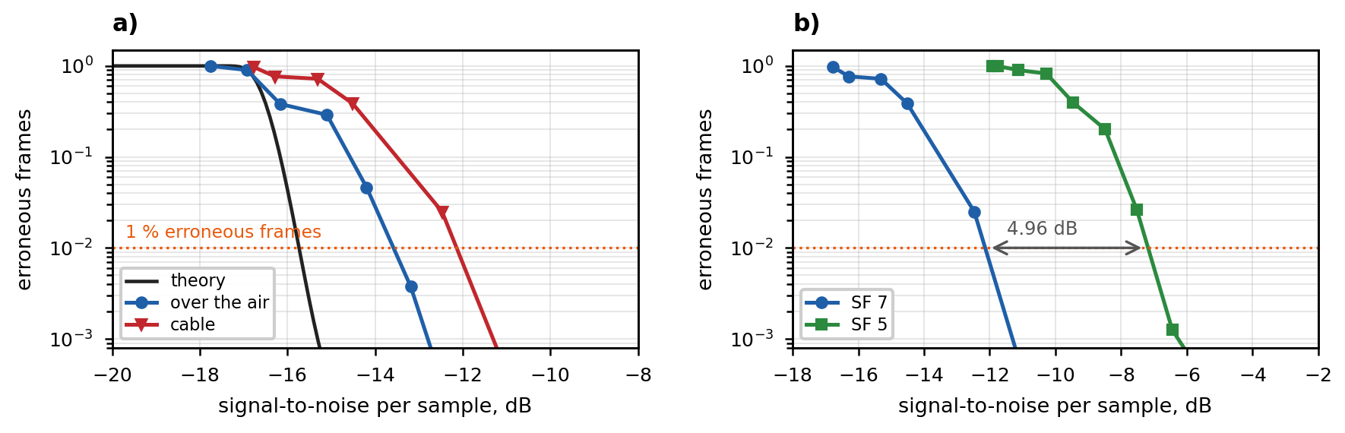
Fig. 4. Packet error rate at $SF=7$ over cable and over the air against the theoretical curve (a) and the two spreading factors over cable (b)
The lower end is limited by the detection, not by the symbol decision. Demodulation alone, with a known frame start and zero offset, stands 0.03 dB from the theoretical bound for a non-coherent decision among $M$ orthogonal signals, while the threshold for fifty percent detection is −17.5 dB — that is, the detection works below the level at which the frame is decoded.

V. CONCLUSION
A real-time CSS modem has been designed and implemented on a general-purpose computer with two software-defined radio platforms: the receiver acquires the frame on its own in the stream and decodes it at the rate of that stream, with a severalfold margin with respect to real time. The design has been set out — how the symbol and the frame follow from the initial requirements, how the down-chirp delimiter separates the timing from the frequency offset, and how matched filtering over all $M$ candidates decides the symbol.
The measurements: over the air, at the operating gains, not a single erroneous frame and not a single erroneous bit; the sensitivity threshold is taken over the air and over cable at the two spreading factors, and the lower end is limited by the detection, not by the symbol decision. The profile is a baseline and carries no error correction, so what is measured is attributable entirely to the modulation and the synchronization — a reference point against which, on the same equipment and in the same setting, other modulation schemes and the further development of the CSS chain itself can be compared.

ACKNOWLEDGMENTS
This work was supported by the National Scientific Program Security and Defense, funded by the Ministry of Education and Science of the Republic of Bulgaria under grant agreement no. D01-74/19.05.2022.

REFERENCES
1. Adelantado, F., et al. Understanding the Limits of LoRaWAN. IEEE Communications Magazine, 2017, vol. 55, no. 9, pp. 34–40.
2. Afisiadis, O., et al. On the Error Rate of the LoRa Modulation with Interference. IEEE Transactions on Wireless Communications, 2020, vol. 19, no. 2, pp. 1292–1304.
3. Augustin, A., et al. A Study of LoRa: Long Range and Low Power Networks for the Internet of Things. Sensors, 2016, vol. 16, no. 9, art. 1466.
4. Azim, A. W., A. Bazzi, R. Shubair, M. Chafii. Chirp Spread Spectrum-Based Waveform Design and Detection Mechanisms for LPWAN-Based IoT: A Survey. IEEE Access, 2024, vol. 12, pp. 24949–25017.
5. Chiani, M., A. Elzanaty. On the LoRa Modulation for IoT: Waveform Properties and Spectral Analysis. IEEE Internet of Things Journal, 2019, vol. 6, no. 5, pp. 8463–8470.
6. Ghanaatian, R., O. Afisiadis, M. Cotting, A. Burg. LoRa Digital Receiver Analysis and Implementation. In: Proc. IEEE ICASSP, 2019, pp. 1498–1502.
7. Ivanov, I. P. Software-Defined Radio Communication Systems. Sofia: Defence Institute “Prof. Tsvetan Lazarov”, 2025. ISBN 978-619-90024-8-3. (in Bulgarian)
8. Ivanov, I. P., K. G. Aleksandrova. Radio Communication Technologies for Wireless Sensor Networks. In: Proc. International Scientific Conference “HEMUS 2024”, Plovdiv, 2024 (in press). (in Bulgarian)
9. Ivanov, V., A. Manchev. Possibilities for Improving the National Security System. In: Proc. 11th International Scientific Conference “HEMUS 2022”, Plovdiv, 2022, pp. VI-114–VI-124. ISSN 1312-2916. (in Bulgarian)
10. Knight, M., B. Seeber. Decoding LoRa: Realizing a Modern LPWAN with SDR. In: Proc. GNU Radio Conference, 2016, vol. 1, no. 1.
11. LoRa Alliance. TS001-1.0.4 LoRaWAN L2 1.0.4 Specification. 2023.
12. Mitola, J. The Software Radio Architecture. IEEE Communications Magazine, 1995, vol. 33, no. 5, pp. 26–38.
13. Nikolova, P., A. Kolev, P. Gencheva. A Microcontroller System for Collecting Biometric Data in Field Conditions. In: Proc. International Scientific Conference “HEMUS 2024”, Plovdiv, 2024, pp. II-9–II-14. (in Bulgarian)
14. Robyns, P., P. Quax, W. Lamotte, W. Thenaers. A Multi-Channel Software Decoder for the LoRa Modulation Scheme. In: Proc. 3rd International Conference on Internet of Things, Big Data and Security (IoTBDS), 2018, pp. 41–51.
15. Semtech Corporation. AN1200.22 LoRa Modulation Basics. Rev. 2, 2015.
16. Sklar, B., F. Harris. Digital Communications: Fundamentals and Applications. 3rd ed. Pearson Education, 2021.
17. Tapparel, J., O. Afisiadis, P. Mayoraz, A. Balatsoukas-Stimming, A. Burg. An Open-Source LoRa Physical Layer Prototype on GNU Radio. In: Proc. IEEE SPAWC, 2020, pp. 1–5.
18. Wunsch, F., K. Maier, H. Jäkel, F. K. Jondral. Implementation and Performance Evaluation of IEEE 802.15.4 LECIM DSSS PHY at 2.4 GHz. In: Proc. GNU Radio Conference, 2017, vol. 2, no. 1.

COL (Ret.) Assoc. Prof. Eng. Ivan Penchev Ivanov, PhD
Defence Institute “Prof. Tsvetan Lazarov”
Sofia, 1592, 2 Professor Tsvetan Lazarov Blvd, Bulgaria
tel.: +359 2 9221822
e-mail: i.p.ivanov@di.mod.bg

