УПРАВЛЕНИЕ НА ИДЕНТИЧНОСТТА И ДОСТЪПА С IDENTITYSERVER В ПРОТОТИП НА СИСТЕМА ЗА УПРАВЛЕНИЕ НА СЪДЪРЖАНИЕ, БАЗИРАНА НА МИКРОУСЛУГИ

Пламенна Петрова

Резюме: Изследването представя интегрирането на Duende IdentityServer като услуга за токени за сигурност в прототип на CMS с микросървисна архитектура. Решението обединява управлението на потребители, клиенти, роли, разрешения и токени чрез OpenID Connect и OAuth 2.0. JSON Web Tokens (JWTs) се проверяват в API Gateway и отделните услуги, които прилагат собствени политики. Proof Key for Code Exchange (PKCE) обслужва интерактивни клиенти, а Client Credentials – достъпа между приложенията. Експериментите потвърждават коректното прилагане на модела.

Ключови думи: системи за управление на съдържание (CMS), управление на идентичността и достъпа, IdentityServer, микроуслуги, OpenID Connect и OAuth 2.0

IDENTITY AND ACCESS MANAGEMENT WITH IDENTITYSERVER IN A MICROSERVICE-BASED CONTENT MANAGEMENT SYSTEM PROTOTYPE

Plamenna Petrova

Abstract: This study presents Duende IdentityServer as a security token service (STS) in a microservice-based CMS prototype. The design centralizes users, clients, roles, permissions, and tokens through OpenID Connect and OAuth 2.0. JWTs are validated by the API Gateway and individual services, which enforce local policies. Proof Key for Code Exchange (PKCE) supports interactive clients, while Client Credentials enables application access. Experiments confirmed correct enforcement of the identity and authorization model.

Keywords: content management systems (CMS), identity and access management, IdentityServer, microservices, OpenID Connect and OAuth 2.0

1. INTRODUCTION
Modern content management systems (CMS) offer schema administration, authoring, asset management, editorial review, publication, configuration, and reporting to people and software clients with different responsibilities. A microservice decomposition makes these capabilities independently deployable, but it also replaces a single application security boundary with multiple networked entry points and service-owned data stores. Security mapping studies therefore identify authentication, access control, token handling, and interservice trust as recurring architectural concerns [2], [7], [17].
OpenID Connect (OIDC) adds an authentication layer to OAuth 2.0, while OAuth grants can delegate access to protected resources [8], [14]. JSON Web Tokens (JWTs) can convey signed identity and authorization claims between independently deployed components [9]. Their use alone, however, does not define where identities are authenticated, how public and confidential clients obtain tokens, or where domain permissions are enforced. In this setting, their secure application requires distinguishing public from confidential clients, constraining delegated access, and enforcing authorization at every protected service boundary [11], [15].
An implemented identity and access management (IAM) design for an existing .NET-based microservice CMS prototype is described in the current study, in which Duende IdentityServer is integrated as a security token service (STS), along with an administrative client, API Gateway, independent resource services, role-to-permission mapping, and protocol-level verification. Centralized authentication and token issuance are split from domain authorization: the STS manages users, clients, scopes, resources, grants, roles, and permission claims, whereas the Gateway and each service validate access tokens and enforce local policies. The evaluation examines Proof Key for Code Exchange (PKCE) login, machine tokens, least privilege, refresh-token rotation, persisted-grant revocation, and rejection of invalid credentials across repeated end-to-end executions.

2. RELATED WORK
Research on microservice security provides both architectural classifications and protocol-level guidance. OAuth 2.0, JWT, OIDC, single sign-on, and API gateways are among the mechanisms most frequently reported in the surveyed literature, although practical evaluation remains limited [2]. Access control and auditing are likewise identified as prominent security concerns [7]. General microservice mapping shows that service decomposition changes deployment and communication boundaries and therefore increases the importance of explicit cross-service contracts [4]. Defense in depth is particularly relevant because compromise or misconfiguration at one boundary should not imply authorization at downstream services [17].
Architecture-pattern surveys distinguish centralized identity provision from authorization enforcement by resource services [3]. A recent proof-of-concept study similarly combines a central identity component with distributed authorization and relates this arrangement to zero-trust principles [1], [12]. The present study applies this separation to CMS editorial permissions and evaluates it through a running Gateway, STS, and destination services instead of isolated token generation. It extends earlier IdentityServer integration work [13] to persisted configuration, operational grants, administrative workflows, client-side PKCE, machine credentials, and granular CMS policies.
The protocol foundations are defined by OAuth 2.0 [8], OIDC [14], JWT [9], and PKCE [15]. Formal analyses identify security conditions for redirect handling, state and nonce correlation, and token processing [5], [6]. Current OAuth security guidance advocates PKCE for public clients, replay detection, audience restriction, and narrowly assigned privileges [11]. Role-based access control supports grouping users by shared responsibilities [16], while workflow authorization research relates roles and separation of duty to task transitions [10].
OAuth scopes, token claims, and grant mechanisms address complementary aspects of access control. Scopes delimit the access requested by a client, whereas the JWT claims communicate information about the authenticated user or machine identity to resource services [8], [9]. Roles may group organizational responsibilities, but operation-specific permissions allow services to make more granular authorization decisions [16]. Grant management also extends beyond initial token issuance because refresh credentials, user consent, rotation, and administrative revocation affect the continuing validity of a session [8], [11].

3. APPROACH

3.1. Trust Boundaries and Claims Model
The security design begins with four trust zones. The browser is treated as a public client and receives no client secret. Confidential machine clients retain credentials outside the browser. The Identity service is the only component that authenticates users and issues protocol tokens, while the Gateway is the public API entry point. Resource services remain separate authorization boundaries because they may be reachable through internal routes or future service-to-service communication. Configuration data and operational grants are distinct from CMS domain data, preventing content services from reading identity tables or deciding how tokens are issued.
Authentication establishes which user or client initiated a request. Authorization determines whether that principal may perform the requested CMS operation. This distinction shapes the claims model. OIDC identity scopes provide subject and profile information for interactive sessions; the API scope identifies access to the CMS resource; roles group common responsibilities; and permission claims express operations such as content creation, content publication, report access, user management, and identity management. Services require permissions rather than assuming that possession of a role or an access token is sufficient. This design also permits a custom role to receive selected permissions without changing the source code of every service.
The examined threats, architectural controls, and verification evidence can be summarized as:
- Authorization-code interception: S256 PKCE binds the authorization code to the browser verifier; requests using an incorrect verifier and attempts to reuse an authorization code are rejected.
- Gateway bypass: Resource services independently validate JWTs and enforce authorization policies, while missing and modified tokens are rejected at both Gateway and service boundaries.
- Refresh-token replay: One-time refresh-token use and rotation prevent credential reuse and attempts to reuse a consumed refresh token result in failure.
- Continued renewal after revocation: Administrative deletion of the persisted grant prevents subsequent refresh, although previously issued access JWTs remain valid until expiry.
3.2. IdentityServer Persistence and Client Grants
The Identity service acts as the STS and combines Duende IdentityServer with ASP.NET Core Identity. Three SQLite persistence concerns are separated: users and roles, IdentityServer configuration, and operational grants. The configuration model includes clients, identity and API resources, scopes, claims, redirect URIs, lifetimes, and secrets. Operational data retains authorization codes, refresh tokens, consents, and related persisted grants. The administrative client manages these resources through protected endpoints and also provides account, password, email-confirmation, role, permission, and time-based one-time-password functions. The central issuance boundary and the distributed validation points are shown in Figure 1.
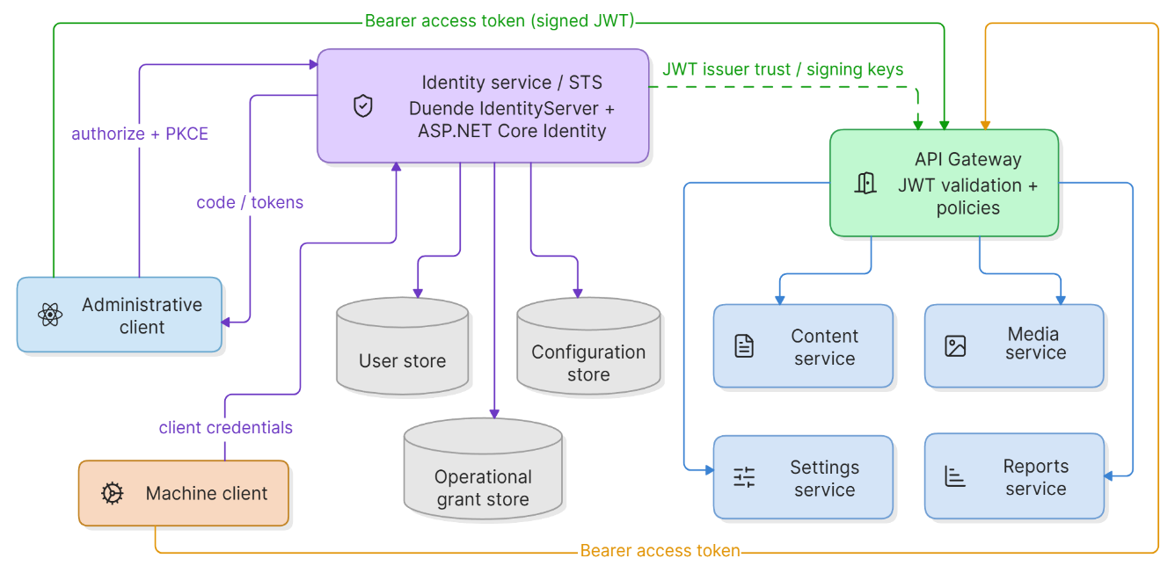
Fig. 1. Identity issuance and authorization boundaries in the CMS prototype
Interactive users employ Authorization Code with PKCE. The client generates a verifier, derives its S256 challenge, and sends state and nonce values with the authorization request. Following authentication, it exchanges the returned code and verifier for signed tokens and uses the access token for APIs. Machine clients use Client Credentials and receive an application identity without a human subject or user role. API resources and scopes delimit client access to protected CMS interfaces, while granular permission claims constrain the operations permitted within those interfaces.

3.3. Distributed Validation and CMS Policies
The Gateway validates access tokens before reverse proxying requests, but resource services do not rely solely on that decision. The Content, Media, Settings, and Reports services validate issuer, audience, signature, and lifetime independently and apply the same named permission policies. This arrangement limits accidental exposure through a direct service route and reflects a zero-trust assumption that network placement is not sufficient evidence of authority. Domain services retain final control: the Identity service assigns claims, while the Content service determines whether a content-creation or content-publication permission claim is required, and the Reports service requires a report-reading permission claim. The roles and client privileges are outlined in Table 1.
Table 1. Representative role and client privileges
Principal | Representative allowed operations | Representative denied operations
Viewer | Read content, media, and settings | Create, publish, administration
Author | Create/edit content, upload media | Publish, identity administration
Editor | Author rights, publish, read reports | Identity and user administration
Administrator | All defined CMS and IAM permissions | None within configured scope
Reports machine client | Read reports only | Content, schema, workflow, and IAM writes
The model supports separation of duty in editorial workflows. Roles are convenient policy bundles, not the final authorization unit: permission names cover content, media, settings, reporting, user management, and identity configuration. Custom roles can receive selected permission claims, and policies check those claims at the protected operation. It thus avoids embedding a fixed set of role names in every service. Figure 2 illustrates the Authorization Code with PKCE request sequence. IdentityServer authenticates the user and issues the access token, whereas the Gateway and destination service independently validate that token and apply the relevant permission policy. Consequently, successful authentication does not by itself authorize a protected CMS operation.
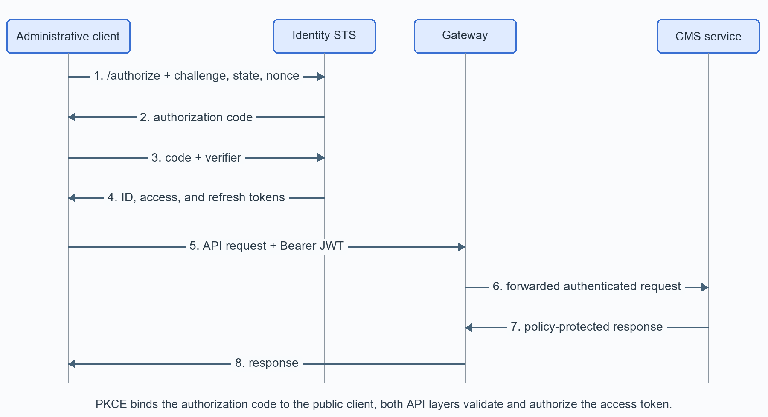
Fig. 2. Authorization Code with PKCE and defense-in-depth API authorization

  - Experimental Analysis

Evaluation Environment and Procedure
The evaluation used the running Docker Compose topology on a Windows 11 Pro host equipped with an AMD Ryzen 5 5600H processor featuring six physical cores and twelve logical processors, 16 GiB of RAM, and an NVMe solid-state drive. It exercised the IdentityServer, Gateway, Content, and Reports services through HTTP in three measured batches. Parallelism levels one, two, and four were executed in ascending order, with 100 complete suite executions at each level. Every execution created uniquely named interactive and machine clients, performed in verification groups, and removed its temporary clients and grants during cleanup. Concurrent executions used independent HTTP clients and identifiers but shared the same local service instances and persistence stores.
The verification scenarios represented an administrative client using Authorization Code with PKCE, CMS users governed by role and permission claims, a reports-only machine client using Client Credentials, and renewable-credential management. Positive and negative checks examined token claims, protocol correlation, authorization at Gateway and service boundaries, invalid credentials and scopes, modified tokens, code and refresh-token reuse, persisted-grant revocation.
For every parallelism level, the analysis calculated successful execution rate, elapsed batch time, complete-suite throughput, verification-group throughput, speedup, and parallel efficiency. Median, nearest-rank p95 and p99, and p95-to-median tail amplification were calculated for selected verification groups at parallelism four. Batch throughput includes process scheduling and orchestration, whereas group durations cover multi-request protocol paths and are not isolated endpoint latencies.

Performance Results and Interpretation
All complete executions succeeded, yielding 3,900 verification groups and 11,100 asserted outcomes. The workload was distributed evenly across the three parallelism levels - 100 suites and 3,700 asserted outcomes per level - allowing direct comparison of elapsed time, throughput, speedup, and parallel efficiency, as reported in Table 2.
Table 2. Throughput and scaling of complete IAM suite executions
Parallelism | Elapsed (s) | Elapsed reduction (%) | Suite rate (/s) | Group rate (/s) | Speedup | Efficiency (%)
1 | 139.835 | 0.000 | 0.715 | 9.297 | 1.000 | 100.000
2 | 66.788 | 52.238 | 1.497 | 19.465 | 2.094 | 104.686
4 | 34.427 | 75.380 | 2.905 | 37.761 | 4.062 | 101.545
For the same execution workload, elapsed batch time fell from 139.835 s at parallelism one to 66.788 s at two and 34.427 s at four, reductions of 52.238% and 75.380%. Complete-suite throughput rose from 0.715 to 1.497 and 2.905 executions/s, while verification-group throughput increased from 9.297 to 19.465 and 37.761 groups/s. The corresponding speedups were 2.094 and 4.062.
Calculated efficiencies were 104.686% at parallelism two and 101.545% at four. Per-worker suite rates were 0.715, 0.749, and 0.726 executions/s, remaining close to the single-worker rate. The values above 100% are therefore consistent with small timing effects from ascending batches, warmed services, just-in-time compilation, operating-system scheduling, and measurement granularity rather than superlinear scalability. Table 3 then presents the latency distributions of selected authentication, authorization, validation, and credential-lifecycle groups at parallelism four.
Table 3. Selected group-duration distributions at parallelism four
Verification group | Median (ms) | p95 (ms) | p99 (ms) | p95/median
Administrator login and PKCE bootstrap | 232.5 | 382 | 408 | 1.643
Interactive PKCE token and profile | 162.0 | 320 | 332 | 1.975
Incorrect PKCE verifier rejection | 126.5 | 167 | 299 | 1.320
Client Credentials machine token | 12.0 | 16 | 20 | 1.333
Missing or modified JWT rejection | 30.0 | 50 | 285 | 1.667
Reports-only policy enforcement | 102.0 | 145 | 330 | 1.422
Refresh rotation and replay denial | 27.0 | 180 | 331 | 6.667
Grant revocation behavior | 62.5 | 108 | 218 | 1.728
Temporary client provisioning | 48.0 | 194 | 205 | 4.042
Among the measured groups, Client Credentials issuance was the shortest, with a 12 ms median and 16 ms p95. Administrator bootstrap and interactive PKCE processing had medians of 232.5 and 162.0 ms because they cover authorization, token exchange, validation, and protected API access. Refresh rotation and replay denial had the largest p95-to-median ratio (6.667), followed by temporary client provisioning (4.042). Both write to IdentityServer stores, making persistence or host scheduling plausible contributors, although causality was not isolated. JWT rejection had a p99 of 285 ms despite a 50 ms p95, indicating a small number of outliers.
These performance measurements characterize complete verification paths, not isolated endpoint service times. They show repeatable execution under the tested parallel workloads, but the run samples and single-host procedure do not establish a production capacity threshold. A dedicated load generator, randomized load order, clean snapshots, controlled warm-up, and larger samples are required before attributing scaling effects to IdentityServer or comparing its performance with another STS.

  - Observed Security Behavior
Performance was interpreted only after confirming that the expected protocol and authorization behavior remained unchanged at every tested parallelism level. This ordering precluded improvements in execution rate from being considered valid if they altered token contents, policy decisions, or credential-lifecycle outcomes. Experimental IAM dimensions and observed behavior were as follows:
- Protocol capability: Discovery advertised Authorization Code, S256 PKCE, and Client Credentials, confirming that the STS supported the required interactive and machine flows.
- Interactive identity integrity: Consistent issuer, audience, signature, lifetime, state, nonce, user profile information, role, and permission checks demonstrated a coherent user and client identity context.
- Machine identity isolation: The application token contained the client identity and a report-reading permission, but no user subject or role, establishing a separate least-privilege machine identity.
- Authentication failure handling: Incorrect verifiers, reused codes, invalid secrets or scopes, and invalid JWTs produced the expected OAuth or HTTP errors before domain operations were executed.
- Authorization discrimination: Reports access was permitted while unrelated CMS and IAM operations were forbidden, showing that authentication did not imply unrestricted access.
- Distributed enforcement: Independent validation was confirmed at the resource-service boundaries.
- Credential lifecycle: Refresh-token rotation succeeded, whereas replay and post-revocation renewal were denied. Grant deletion prevented renewal but did not invalidate an unexpired self-contained JWT.
- Configuration isolation: Temporary clients and grants were absent after every cleanup, preventing repeated executions from accumulating test configuration.
The observations distinguish authentication failure from authorization denial. Incorrect protocol credentials produced invalid grant, invalid client, or invalid scope responses; missing or signature-modified bearer tokens produced HTTP 401 and authenticated principals lacking a required permission produced HTTP 403. The same invalid-token material was rejected through Gateway routes and at direct Content and Reports endpoints, while permitted requests succeeded through both paths. These outcomes show that destination services retained authorization responsibility in the examined topology.
Refresh credentials rotated, reuse of a consumed credential failed, and deletion of the persisted grant prevented later renewal. The access JWT issued before deletion remained usable until expiry, as expected for a self-contained token validated without consulting the authorization server. The experiments therefore verified control over renewable session state rather than immediate revocation of every issued credential.

4. DISCUSSION AND LIMITATIONS
The findings indicate that centralized identity can coexist with autonomous CMS authorization boundaries. IdentityServer issues constrained credentials, the Gateway establishes the external boundary, and destination services retain domain authority through independent JWT validation and permission policies. The human and machine scenarios show that authentication alone does not authorize every CMS capability. Persisted-grant deletion blocks renewal but cannot retract an unexpired self-contained JWT, and shorter lifetimes or revocation-aware tokens could reduce this interval at additional operational cost. Defense-in-depth also requires consistent issuer, audience, permission, key, and secret governance.
The evaluation remains preliminary: it used one development host, HTTP, development credentials and signing material, shared SQLite stores, retained volumes, and executions at each of three ascending parallelism levels. However, it did not feature browser-interface automation, penetration testing, formal OIDC conformance testing, comparative STS evaluation, or distributed-failure analysis. Email delivery, full multifactor and custom-role administration, key rotation, multitenancy, and immediate access-token revocation were also outside the suite. Future work should rely on HTTPS, protected signing keys, randomized higher loads, distributed hosts, controlled faults, and security abuse cases.

5. CONCLUSION
This study implemented Duende IdentityServer as the STS of a microservice-based CMS and connected protocol-level identity management to domain-specific authorization. Authorization Code with PKCE supports the administrative client, Client Credentials supports independent machine access, and signed JWTs carry constrained identity and permission claims. Validation at both the Gateway and service boundaries preserves defense in depth, while local policies retain control over content, media, configuration, reporting, user, and identity operations. All repeated end-to-end executions completed successfully and satisfied the defined experimental assertions. Throughput increased across parallelism levels one, two, and four while every execution retained the expected authentication, least-privilege, refresh-rotation, and grant-revocation behavior. These results furnish initial evidence that the architecture can support coherent CMS access decisions at the tested parallelism levels, but they do not establish production-scale capacity or comparative STS performance. Hence, continued work on the study will be set to evaluate higher concurrent authorization traffic, distributed deployment, hardened signing-key and secret management with the CMS expansion, as well as multitenancy, protocol conformance, fault injection, and security testing against realistic client and editorial workloads.

REFERENCES
[1] ALDEA, Constantin Lucian; BOCU, Razvan. Authentication Challenges
and Solutions in Microservice Architectures. Applied Sciences. 2025, 15(22), 12088. DOI 10.3390/app152212088.
[2] ALMEIDA, Murilo Goes de; CANEDO, Edna Dias. Authentication and
Authorization in Microservices Architecture: A Systematic Literature Review. Applied Sciences. 2022, 12(6), 3023. DOI 10.3390/app12063023.
[3] BARABANOV, Alexander; MAKRUSHIN, Denis. Authentication and
authorization in microservice-based systems: survey of architecture patterns. arXiv. 2020, arXiv:2009.02114.
[4] DI FRANCESCO, Paolo; LAGO, Patricia; MALAVOLTA, Ivano.
Architecting with microservices: A systematic mapping study. Journal of Systems and Software. 2019, 150, 77-97. DOI 10.1016/j.jss.2019.01.001.
[5] FETT, Daniel; KUSTERS, Ralf; SCHMITZ, Guido. A Comprehensive
Formal Security Analysis of OAuth 2.0. In: Proceedings of the 2016 ACM SIGSAC Conference on Computer and Communications Security. 2016, pp. 1204-1215. DOI 10.1145/2976749.2978385.
[6] FETT, Daniel; KUSTERS, Ralf; SCHMITZ, Guido. The Web SSO
Standard OpenID Connect: In-Depth Formal Security Analysis and Security Guidelines. In: 2017 IEEE 30th Computer Security Foundations Symposium. 2017, pp. 189-202. DOI 10.1109/CSF.2017.20.
[7] HANNOUSSE, Abdelhakim; YAHIOUCHE, Salima. Securing
microservices and microservice architectures: A systematic mapping study. Computer Science Review. 2021, 41, 100415. DOI 10.1016/j.cosrev.2021.100415.
[8] HARDT, Dick. The OAuth 2.0 Authorization Framework. RFC 6749.
Internet Engineering Task Force, 2012. DOI 10.17487/RFC6749.
[9] JONES, Michael; BRADLEY, John; SAKIMURA, Nat. JSON Web
Token (JWT). RFC 7519. Internet Engineering Task Force, 2015. DOI 10.17487/RFC7519.
[10] LIU, Duen-Ren; WU, Mei-Yu; LEE, Shu-Teng. Role-based
authorizations for workflow systems in support of task-based separation of duty. Journal of Systems and Software. 2004, 73(3), 375-387. DOI 10.1016/S0164-1212(03)00175-4.
[11] LODDERSTEDT, Torsten; BRADLEY, John; LABUNETS, Andrey;
FETT, Daniel. Best Current Practice for OAuth 2.0 Security. RFC 9700. Internet Engineering Task Force, 2025. DOI 10.17487/RFC9700.
[12] NATIONAL INSTITUTE OF STANDARDS AND TECHNOLOGY.
Zero Trust Architecture. NIST Special Publication 800-207. Gaithersburg: NIST, 2020. DOI 10.6028/NIST.SP.800-207.
[13] PETROVA, Plamenna; VARBANOVA, Silviya. IdentityServer
Integration with ASP.NET Core. Mathematics, Computer Science and Education. 2023, 6(1), 40–47. DOI 10.54664/XRYI9517.
[14] SAKIMURA, Nat; BRADLEY, John; JONES, Michael; DE
MEDEIROS, Breno; MORTIMORE, Chuck. OpenID Connect Core 1.0 incorporating errata set 2. Online. OpenID Foundation, 2023 [viewed 5 September 2026]. Available from: https://openid.net/specs/openid-connect-core-1_0.html
[15] SAKIMURA, Nat; BRADLEY, John; AGARWAL, Naveen. Proof Key
for Code Exchange by OAuth Public Clients. RFC 7636. Internet Engineering Task Force, 2015. DOI 10.17487/RFC7636.
[16] SANDHU, Ravi S.; COYNE, Edward J.; FEINSTEIN, Hal L.;
YOUMAN, Charles E. Role-Based Access Control Models. Computer. 1996, 29(2), 38-47. DOI 10.1109/2.485845.
[17] YARYGINA, Tatiana; BAGGE, Anya Helene. Overcoming Security
Challenges in Microservice Architectures. In: 2018 IEEE Symposium on Service-Oriented System Engineering. 2018, pp. 11-20. DOI 10.1109/SOSE.2018.00011.

Plamenna Viktorova Petrova, PhD Student
St. Cyril and St. Methodius University of Veliko Tarnovo,
T. Tarnovski Str. 2, Veliko Tarnovo 5000
phone: +359 899 566 319; e-mail: plamennavp@abv.bg

