DIGITAL TRANSFORMATION OF INNOVATION MANAGEMENT IN INDUSTRIAL ORGANIZATIONS: INDUSTRY 5.0 PERSPECTIVES

Tsanka Zlateva-Petkova

Abstract: Innovation management in industrial organizations is undergoing a fundamental shift as digitalization reshapes the way organizations generate, evaluate, develop, and implement innovative ideas. Within the Industry 5.0 paradigm, digital transformation extends beyond technological modernization by integrating artificial intelligence, Industrial Internet of Things (IIoT), digital twins, cloud computing, big data analytics, and collaborative digital platforms with human expertise and sustainable development objectives. This paper examines the evolving role of digital transformation in supporting innovation management throughout the entire innovation lifecycle, from idea generation to commercialization. The study analyzes the technological foundations, organizational implications, and strategic challenges associated with the adoption of intelligent technologies in industrial environments. A conceptual perspective of the Industry 5.0 innovation ecosystem is presented to illustrate the interactions between digital technologies, organizational capabilities, stakeholders, and sustainability principles. The findings emphasize that successful innovation management increasingly depends on the effective integration of digital intelligence, human creativity, and continuous organizational learning. The paper contributes to the understanding of digital transformation as a strategic enabler of innovation management and outlines future directions for developing more integrated and intelligent innovation ecosystems in industrial organizations.

Keywords: innovation management, Industry 5.0, artificial intelligence, digital technologies, intelligent systems.

I. Introduction
The accelerating pace of technological development has significantly reshaped the competitive landscape of industrial organizations. Digital transformation has evolved from a technology-oriented initiative into a strategic imperative that influences organizational structures, business processes, and innovation capabilities. The integration of advanced digital technologies enables organizations to improve operational efficiency, enhance decision-making processes, and accelerate the development of innovative products, services, and business models.
Innovation management has become one of the most critical organizational functions in this new digital environment. Traditional innovation processes, often characterized by sequential decision-making and limited information exchange, are gradually being replaced by dynamic, data-driven, and collaborative approaches supported by intelligent digital technologies. Artificial intelligence, Industrial Internet of Things (IIoT), big data analytics, cloud computing, blockchain, and digital twins provide organizations with new opportunities to identify market needs, optimize research and development activities, predict technological trends, and reduce uncertainty throughout the innovation lifecycle.
The transition from Industry 4.0 to Industry 5.0 further extends the role of digital transformation by emphasizing human-centricity, resilience, and sustainability alongside technological advancement. Rather than focusing exclusively on automation and productivity, Industry 5.0 promotes the collaboration between intelligent technologies and human expertise to create sustainable value for organizations and society. Consequently, innovation management increasingly requires the integration of technological intelligence with organizational knowledge, employee creativity, and stakeholder collaboration.
Despite the growing body of research on digital transformation and Industry 5.0, existing studies frequently examine individual technologies or isolated innovation activities without providing a comprehensive understanding of their combined impact on innovation management. This fragmented perspective limits the ability of industrial organizations to exploit the full potential of digital transformation in developing sustainable innovation capabilities.
Therefore, the aim of this paper is to analyze the impact of digital transformation on innovation management in industrial organizations from the perspective of Industry 5.0. The study examines the role of intelligent digital technologies throughout the innovation process, discusses the associated organizational challenges and opportunities, and presents a conceptual view of the digital innovation ecosystem that supports sustainable and human-centric innovation management.
II. Digital Transformation and the Evolution of Innovation Management
Digital transformation has become one of the primary drivers of organizational innovation in modern industrial enterprises. While early approaches to innovation management primarily focused on improving research and development activities, contemporary organizations increasingly recognize innovation as a continuous, data-driven process supported by advanced digital technologies. This transformation extends beyond the implementation of new technologies, encompassing fundamental changes in organizational structures, business models, decision-making mechanisms, and stakeholder collaboration.
Traditionally, innovation management followed a linear sequence consisting of idea generation, product development, testing, market introduction, and performance evaluation. These processes were often characterized by fragmented information flows, lengthy development cycles, and limited organizational flexibility. As industrial competition intensified and technological change accelerated, organizations were required to adopt more agile innovation models capable of responding rapidly to evolving market demands and technological opportunities.
The emergence of Industry 4.0 marked a significant turning point in the evolution of innovation management. The integration of cyber-physical systems, Industrial Internet of Things (IIoT), cloud computing, big data analytics, and artificial intelligence enabled organizations to collect, process, and utilize vast amounts of operational data in real time. Innovation activities became increasingly supported by predictive analytics, intelligent automation, and digital collaboration platforms, significantly reducing product development time while improving decision quality and resource utilization.
Industry 5.0 further expands this transformation by introducing a human-centric and sustainability-oriented perspective to industrial innovation. Rather than viewing technology as an end in itself, Industry 5.0 emphasizes the complementary relationship between intelligent digital systems and human expertise. Employees are no longer considered passive operators within automated environments but active contributors whose creativity, experience, and interdisciplinary knowledge enhance the effectiveness of digital technologies throughout the innovation process.
Consequently, innovation management has evolved from a technology-centered function into an integrated organizational capability that combines digital intelligence with human creativity, strategic leadership, and sustainable value creation. Organizations increasingly rely on cross-functional collaboration, digital ecosystems, and knowledge-sharing platforms that facilitate continuous learning and accelerate innovation cycles. This integrated approach enables industrial enterprises to improve resilience, increase adaptability to market changes, and strengthen long-term competitiveness.
The evolution of innovation management can therefore be interpreted as a transition through four successive stages. The first stage is characterized by traditional innovation management, relying predominantly on experience-based decision-making and sequential development processes. The second stage introduces digitalization, where information technologies improve communication, documentation, and process automation. The third stage corresponds to Industry 4.0, in which interconnected intelligent systems enable real-time monitoring, data-driven decision-making, and predictive capabilities. Finally, Industry 5.0 establishes a human-centric innovation paradigm that integrates intelligent technologies with sustainability principles, organizational resilience, and collaborative knowledge creation.
Figure 1 illustrates this evolutionary transition by highlighting the progressive integration of digital technologies, organizational capabilities, and human-centric principles that characterize innovation management in the Industry 5.0 era.
This progressive evolution demonstrates that digital transformation is no longer solely a technological initiative but a strategic enabler of innovation management. The successful integration of digital technologies with organizational capabilities provides industrial organizations with the foundation for achieving continuous innovation, sustainable development, and long-term competitive advantage.
Building upon this evolution, the following section examines the intelligent digital technologies that currently constitute the technological foundation of innovation management in Industry 5.0 industrial organizations.
III. Intelligent Technologies Supporting Innovation Processes
The successful implementation of digital transformation largely depends on the effective adoption of intelligent technologies that support decision-making, knowledge management, and continuous innovation. Within the Industry 5.0 paradigm, these technologies function as complementary components of an integrated innovation environment, enabling industrial organizations to increase flexibility, improve operational efficiency, and accelerate the development of new products, services, and business models.

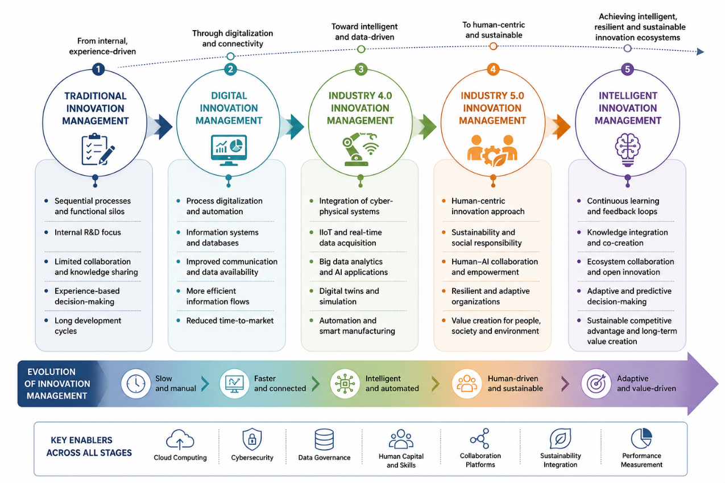

Figure 1 – Evolution of Innovation Management in the Digital Era

Artificial Intelligence (AI) has become one of the most influential technologies in contemporary innovation management. Machine learning algorithms, predictive analytics, and generative AI applications enable organizations to analyze complex datasets, identify hidden patterns, forecast market trends, and support strategic decision-making. AI also facilitates idea generation, technology scouting, customer behavior analysis, and optimization of research and development activities, significantly reducing the time required to transform innovative concepts into market-ready solutions.
The Industrial Internet of Things (IIoT) provides the real-time connectivity required for intelligent innovation processes. By integrating sensors, machines, production systems, and digital communication networks, IIoT continuously collects operational data that support product improvement, process optimization, predictive maintenance, and rapid identification of production bottlenecks. This continuous data flow enhances organizational responsiveness and provides valuable feedback throughout the innovation lifecycle.
Big Data Analytics further strengthens innovation management by transforming large volumes of structured and unstructured data into actionable knowledge. Modern industrial organizations utilize advanced analytical techniques to evaluate customer requirements, monitor production performance, identify emerging market opportunities, and assess innovation outcomes. Data-driven insights enable managers to reduce uncertainty and make evidence-based strategic decisions.
Cloud Computing has become an essential technological infrastructure supporting collaborative innovation. Cloud-based platforms facilitate secure information sharing, distributed project management, remote collaboration, and scalable computing resources. They enable geographically dispersed teams, research institutions, suppliers, and industrial partners to cooperate efficiently throughout product development and innovation implementation.
Digital Twins represent one of the most advanced applications of digital transformation in industrial environments. By creating dynamic virtual representations of physical products, manufacturing systems, or production processes, digital twins enable organizations to simulate operational scenarios, evaluate design alternatives, predict system behavior, and optimize innovation decisions before physical implementation. This capability significantly reduces development costs, minimizes technical risks, and shortens innovation cycles.
Blockchain technology contributes to innovation management by ensuring transparency, traceability, and trust in collaborative innovation networks. Distributed ledger technologies enable secure intellectual property management, verification of digital transactions, protection of innovation-related documentation, and reliable collaboration among multiple stakeholders participating in innovation ecosystems.
Knowledge Management Systems integrate organizational knowledge generated from employees, digital platforms, customers, suppliers, and research institutions into a unified knowledge base. These systems support organizational learning, facilitate knowledge sharing, preserve critical expertise, and improve the efficiency of innovation processes by ensuring that valuable experience remains accessible across the organization.
The effectiveness of these technologies is significantly enhanced when they operate as interconnected elements rather than isolated digital solutions. Industry 5.0 promotes the development of integrated digital environments in which artificial intelligence processes operational data collected through IIoT infrastructures, cloud platforms provide computational resources, digital twins simulate innovation alternatives, blockchain ensures secure collaboration, and knowledge management systems continuously enrich organizational intelligence. Human expertise remains the central coordinating element that interprets analytical results, validates strategic decisions, and transforms technological capabilities into sustainable innovation outcomes.
Consequently, intelligent technologies should not be viewed merely as instruments for process automation but as strategic enablers that fundamentally reshape the way industrial organizations generate, evaluate, implement, and continuously improve innovation.
While intelligent technologies provide the technological foundation for innovation, their strategic value emerges through their application across the different stages of the innovation lifecycle. The following section examines how digital transformation supports each phase of the innovation process, from idea generation to commercialization and continuous improvement.

Table 1 –Intelligent Technologies Supporting Innovation Management in Industry 5.0

Technology | Primary Role in Innovation Management | Main Benefits | Typical Industrial Applications
Artificial Intelligence | Intelligent decision support and predictive analytics | Faster decision-making, improved forecasting, enhanced creativity | Idea generation, demand forecasting, R&D optimization
Industrial Internet of Things (IIoT) | Real-time operational data acquisition | Improved visibility, process optimization, predictive maintenance | Smart factories, connected production systems
Big Data Analytics | Data-driven performance evaluation | Better strategic decisions, market intelligence | Customer analytics, innovation performance assessment
Cloud Computing | Collaborative digital infrastructure | Scalability, flexibility, remote collaboration | Innovation platforms, distributed development teams
Digital Twins | Virtual simulation and system optimization | Reduced development cost and risk, accelerated innovation | Product design, manufacturing optimization, process simulation
Blockchain | Secure information exchange and traceability | Transparency, trust, intellectual property protection | Collaborative innovation networks, supply chain innovation
Knowledge Management Systems | Organizational knowledge integration | Continuous learning, knowledge sharing, improved innovation capability | Corporate knowledge repositories, innovation databases

IV. Digital Transformation Across the Innovation Lifecycle
Digital transformation has fundamentally redefined the innovation lifecycle by enabling continuous information exchange, real-time decision-making, and intelligent process optimization. Unlike traditional linear innovation models, contemporary innovation management is characterized by iterative development, cross-functional collaboration, and data-driven feedback mechanisms that enhance organizational adaptability and accelerate value creation.
The innovation lifecycle generally comprises five interconnected stages: idea generation, idea evaluation, innovation development, implementation, and commercialization. Within Industry 5.0, each stage is supported by intelligent digital technologies that improve efficiency, reduce uncertainty, and strengthen collaboration between human expertise and digital intelligence.
The idea generation stage increasingly relies on artificial intelligence, big data analytics, and digital collaboration platforms. Organizations analyze customer feedback, market trends, competitor activities, and technological developments to identify new opportunities for innovation. AI-assisted data mining and generative technologies facilitate creative thinking by providing evidence-based recommendations and identifying patterns that may remain unnoticed through conventional analytical approaches.
During the idea evaluation stage, decision-makers assess the technical feasibility, economic viability, strategic alignment, and sustainability of proposed innovations. Predictive analytics, simulation tools, and multi-criteria decision-support systems enable organizations to compare alternative solutions using quantitative performance indicators, thereby reducing investment risks and improving resource allocation.
The innovation development stage benefits from the integration of digital twins, cloud computing, and collaborative engineering platforms. Virtual prototyping, digital simulations, and shared development environments allow multidisciplinary teams to optimize product design, validate engineering solutions, and detect potential design flaws before physical implementation. This significantly shortens development cycles while reducing material waste and development costs.
During implementation, Industrial Internet of Things (IIoT), cyber-physical systems, and intelligent manufacturing technologies ensure effective integration of innovations into industrial operations. Real-time monitoring, automated process control, and predictive maintenance improve production stability and facilitate rapid adaptation to changing operational conditions. Simultaneously, digital communication platforms support knowledge sharing and employee engagement throughout organizational change.
The final stage, commercialization and continuous improvement, extends beyond market introduction by incorporating continuous performance evaluation and organizational learning. Customer feedback, operational data, sustainability indicators, and market intelligence are continuously collected and analyzed to identify opportunities for product enhancement and future innovation. This closed-loop approach transforms innovation management into an ongoing learning process rather than a sequence of isolated projects.
An important characteristic of Industry 5.0 is that digital transformation does not replace human decision-making but augments it. Intelligent technologies provide analytical capabilities, predictive insights, and operational support, while managers, engineers, and innovation teams contribute strategic judgment, creativity, ethical considerations, and domain expertise. This complementary relationship establishes a balanced innovation environment where technological intelligence and human capabilities jointly contribute to sustainable organizational development.
Overall, digital transformation enables industrial organizations to establish an adaptive innovation lifecycle that continuously integrates technological advancements, organizational knowledge, and stakeholder collaboration. Such an approach strengthens organizational resilience, accelerates innovation performance, and enhances long-term competitiveness in increasingly dynamic industrial environments.
The digital transformation of individual innovation processes naturally extends toward the broader innovation ecosystem, where organizations, technologies, knowledge networks, and stakeholders interact to create sustainable value. The following section examines this ecosystem from the perspective of Industry 5.0.
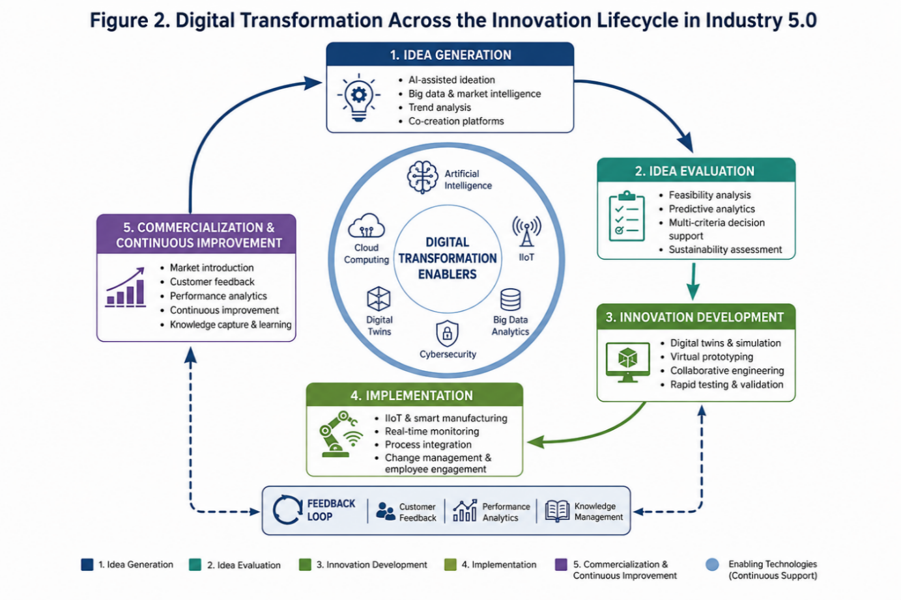

Figure 2 – Digital technologies supporting the main stages of the innovation lifecycle in Industry 5.0 industrial organizations.

V. Innovation Ecosystem in Industry 5.0
Innovation management in Industry 5.0 extends beyond the boundaries of individual organizations and evolves into a dynamic innovation ecosystem in which digital technologies, human expertise, organizational capabilities, and external stakeholders interact to create sustainable value. Unlike traditional innovation systems that primarily focus on internal research and development activities, the Industry 5.0 ecosystem promotes open collaboration, continuous knowledge exchange, and shared innovation across interconnected industrial networks.
At the center of this ecosystem lies innovation management, which coordinates technological resources, organizational knowledge, strategic objectives, and stakeholder relationships throughout the innovation lifecycle. Its primary role is to ensure that innovation activities remain aligned with business strategy while simultaneously addressing sustainability objectives, customer expectations, and technological developments.
Artificial intelligence serves as the analytical core of the ecosystem by transforming operational and market data into strategic knowledge. Through predictive analytics, intelligent decision support, and machine learning algorithms, AI enhances the organization's ability to identify innovation opportunities, evaluate alternatives, and optimize resource allocation. However, these analytical capabilities achieve their greatest value only when combined with human expertise and organizational experience.
Human capital remains the defining element of Industry 5.0 innovation. Engineers, managers, researchers, and multidisciplinary innovation teams contribute creativity, critical thinking, ethical judgment, and problem-solving capabilities that cannot be fully replicated by intelligent technologies. Consequently, successful innovation management depends on effective collaboration between digital intelligence and human decision-makers, creating a balanced environment where technology augments rather than replaces human capabilities.
Digital infrastructure forms the technological backbone of the innovation ecosystem. Industrial Internet of Things (IIoT), cloud computing, digital twins, blockchain, and advanced communication platforms enable seamless information exchange between organizational units and external partners. These technologies facilitate real-time collaboration, secure knowledge sharing, virtual product development, and continuous performance monitoring, thereby increasing both organizational agility and innovation efficiency.
Knowledge management acts as the connecting mechanism that transforms information into organizational intelligence. By integrating knowledge generated from employees, customers, suppliers, universities, research institutions, and industrial partners, organizations establish continuous learning environments capable of supporting sustainable innovation. The systematic accumulation and dissemination of knowledge reduce duplication of effort, accelerate technology transfer, and improve organizational adaptability.
External stakeholders also play an increasingly significant role within the Industry 5.0 innovation ecosystem. Universities and research organizations contribute scientific expertise and technological advances, while suppliers provide specialized knowledge and technological solutions. Customers actively participate through feedback, co-creation initiatives, and market validation, ensuring that innovation activities remain responsive to societal and industrial needs.
Sustainability constitutes the overarching principle connecting all ecosystem components. Innovation decisions are increasingly evaluated not only according to their economic performance but also through their environmental and social impacts. Digital technologies support sustainability by optimizing resource utilization, reducing waste, improving energy efficiency, and facilitating transparent environmental performance monitoring. Consequently, sustainable innovation becomes an integral objective rather than an additional organizational responsibility.
The Industry 5.0 innovation ecosystem therefore represents an interconnected environment where intelligent technologies, human competencies, organizational knowledge, and collaborative networks continuously reinforce one another. Such integration enables industrial organizations to improve resilience, accelerate innovation cycles, strengthen competitive advantage, and create long-term sustainable value.

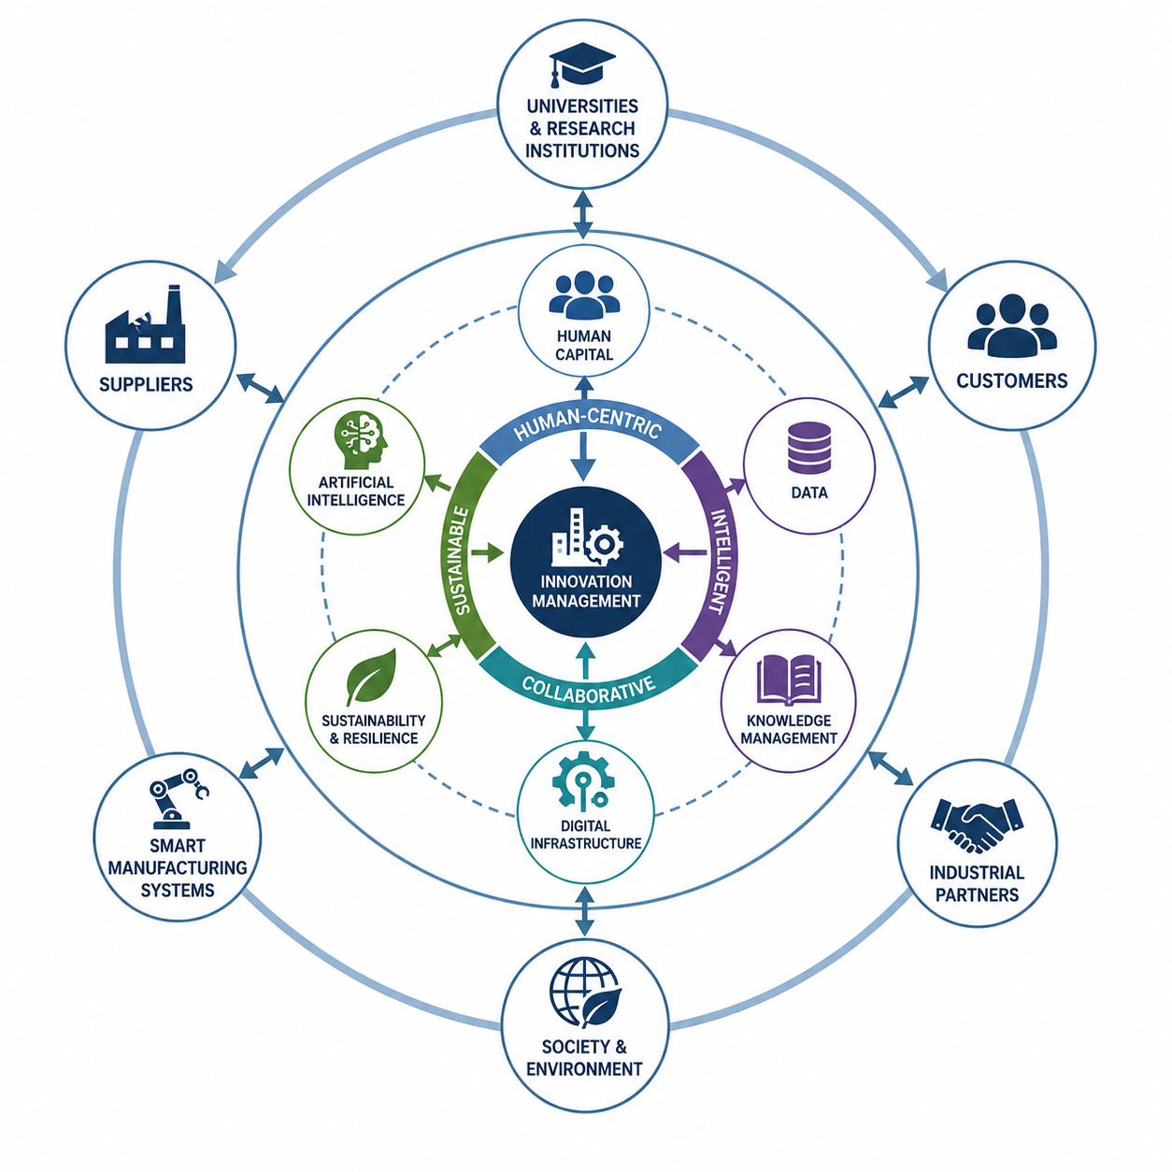
Figure 3 –Conceptual representation of the Industry 5.0 innovation ecosystem integrating intelligent technologies, human expertise, organizational capabilities, and external stakeholders.

Table 2 –Challenges and Opportunities of Digital Innovation Management in Industry 5.0

Dimension | Key Challenges | Potential Opportunities
Technology Integration | Interoperability of heterogeneous digital systems | Integrated digital innovation platforms
Data Management | Data quality, ownership, cybersecurity, and privacy | Real-time analytics and evidence-based decision-making
Human Resources | Digital skills gaps and resistance to organizational change | Continuous learning, reskilling, and human–AI collaboration
Organizational Culture | Limited cross-functional collaboration and innovation readiness | Agile organizational structures and knowledge sharing
Sustainability | Balancing economic, environmental, and social objectives | Sustainable innovation and ESG-oriented value creation
Strategic Management | Aligning digital investments with innovation strategy | Improved competitiveness and long-term organizational resilience

The analysis demonstrates that successful digital innovation management requires a balanced integration of technological capabilities, human competencies, organizational learning, and strategic leadership. Industry 5.0 provides the conceptual foundation for achieving this integration by promoting innovation ecosystems that simultaneously support economic performance, social well-being, and sustainable industrial development.
VI. Conclusions
The digital transformation of industrial organizations is fundamentally reshaping the principles and practices of innovation management. The transition from conventional innovation models toward data-driven, intelligent, and collaborative approaches has significantly expanded the strategic role of digital technologies in supporting innovation throughout the entire organizational lifecycle.
This study examined the evolution of innovation management from traditional approaches to the human-centric philosophy of Industry 5.0. The analysis demonstrated that technologies such as artificial intelligence, Industrial Internet of Things, big data analytics, cloud computing, digital twins, blockchain, and knowledge management systems collectively establish the technological foundation for modern innovation management. Their effective integration enables organizations to accelerate innovation processes, improve decision quality, strengthen organizational learning, and increase long-term competitiveness.
The paper further highlighted that technological advancement alone is insufficient to ensure successful innovation. Human expertise, interdisciplinary collaboration, organizational culture, and sustainability-oriented strategic management remain essential factors for transforming digital capabilities into sustainable innovation outcomes. The proposed conceptual innovation ecosystem illustrates how intelligent technologies, organizational knowledge, and stakeholder collaboration interact to support continuous innovation within Industry 5.0 environments.
From a practical perspective, the presented analysis may assist managers and industrial practitioners in understanding the strategic role of digital transformation in innovation management and in identifying the key technological and organizational factors influencing successful innovation initiatives.
Future research should focus on the development of integrated intelligent frameworks capable of supporting end-to-end innovation management, incorporating advanced decision-support methods, adaptive digital ecosystems, and emerging Industry 5.0 technologies to further strengthen sustainable industrial innovation.

Bibliography:
[1] European Commission, Industry 5.0: A Transformative Vision for Europe, Luxembourg: Publications Office of the European Union, 2021.
[2] X. Xu, Y. Lu, B. Vogel-Heuser, and L. Wang, "Industry 4.0 and Industry 5.0—Inception, conception and perception," Journal of Manufacturing Systems, vol. 61, pp. 530–535, 2021.
[3] A. Maddikunta et al., "Industry 5.0: A survey on enabling technologies and potential applications," Journal of Industrial Information Integration, vol. 26, 2022.
[4] L. Rauch, D. T. Matt, and P. Dallasega, "Human-centered manufacturing in Industry 5.0: A review," Sustainability, vol. 13, no. 15, 2021.
[5] F. Tao, H. Zhang, A. Liu, and A. Y. C. Nee, "Digital Twin in Industry: State-of-the-Art," IEEE Transactions on Industrial Informatics, 2022.
[6] S. Kumar, R. Gupta, and P. Singh, "Artificial Intelligence for Smart Manufacturing: A Review," IEEE Access, vol. 10, 2022.
[7] M. Javaid, A. Haleem, R. P. Singh, and R. Suman, "Industrial Internet of Things (IIoT): Applications and Challenges in Smart Manufacturing," Sensors, vol. 22, 2022.
[8] Y. Lu, X. Xu, and J. Wang, "Smart Manufacturing and Industry 5.0: Digital Transformation Toward Sustainable Production," Robotics and Computer-Integrated Manufacturing, 2022.
[9] A. Frank, L. Dalenogare, and N. Ayala, "Industry 5.0 technologies for sustainable manufacturing," Journal of Cleaner Production, 2022.
[10] M. Massaro, "Electronic Artificial Intelligence and Digital Twins in Industry 5.0: A Systematic Review and Perspectives," Machines, vol. 13, no. 9, 2025.
[11] C. Chen, K. Zhao, J. Leng, C. Liu, J. Fan, and P. Zheng, "Integrating Large Language Models and Digital Twins in the Context of Industry 5.0: Framework, Challenges and Opportunities," Robotics and Computer-Integrated Manufacturing, vol. 94, 2025.
[12] W. Meng et al., "Industrial Digital Twin for Intelligent Manufacturing: Key Technologies, Core Challenges, Applications, and Forward-Looking Trends," Robotics and Computer-Integrated Manufacturing, 2026.
[13] P. Tripicchio, M. Satler, and C. A. Avizzano, "Artificial Intelligence and Digital Twins Applications in Industry 4.0 and 5.0," IntechOpen, 2026.
[14] M. Javaid, A. Haleem, R. P. Singh, R. Suman, and S. Rab, "Big Data Analytics for Smart Manufacturing: Applications and Future Trends," Journal of Industrial Information Integration, 2022.
[15] M. Javaid and A. Haleem, "Cloud Computing Applications in Smart Manufacturing and Industry 5.0," Journal of Industrial Information Integration, 2023.
[16] P. Centobelli, R. Cerchione, and E. Esposito, "Knowledge Management Systems in Digital Transformation: A Systematic Literature Review," Journal of Knowledge Management, 2022.
[17] F. Tao and M. Zhang, "Digital Transformation of Manufacturing Enterprises: Current Trends and Future Directions," Engineering, 2022.
[18] S. Gupta, R. Modgil, and A. Bhushan, "Artificial Intelligence in Innovation Management: A Systematic Literature Review," Technological Forecasting and Social Change, 2023.
[19] A. Nambisan, K. Lyytinen, A. Majchrzak, and M. Song, "Digital Innovation Management: Reinventing Innovation Research in a Digital World," MIS Quarterly Executive, 2022.
[20] R. Vial, "Understanding Digital Transformation: An Updated Review and Research Agenda," Journal of Strategic Information Systems, 2022.
[21] A. Isaza Domínguez, "Digital Twins in Industry 5.0: A Systematic Literature Review," European Public & Social Innovation Review, vol. 9, 2024.
[22] E. Vyhmeister and G. Castane, "When Industry Meets Trustworthy AI: A Systematic Review of AI for Industry 5.0," 2024.
[23] S. Zeb et al., "Industry 5.0 is Coming: A Survey on Intelligent NextG Wireless Networks as Technological Enablers," 2022.
[24] "Digital Twins in the IIoT: Current Practices and Future Directions Toward Industry 5.0," Computers, Materials & Continua, vol. 83, no. 3, 2025.
[25] "Mapping the Industry 5.0 Landscape: Enabling Technologies, Human-Centered Systems, Sectoral Applications, and SDG Alignment—A PRISMA-ScR Review," Technologies, vol. 14, no. 5, 2026.

Assoc. Prof. Eng. Tsanka Marinova Zlateva-Petkova, PhD
Department of Management
Technical University of Gabrovo
4, Hadzhi Dimitar Str.
Gabrovo 5300
Bulgaria
e-mail: tszlateva@abv.bg

