INNOVATION MANAGEMENT IN INDUSTRY 5.0: CURRENT TRENDS AND FUTURE PERSPECTIVES

Tsanka Zlateva-Petkova

Abstract: Industry 5.0 is reshaping innovation management by extending the technology-driven paradigm of Industry 4.0 toward a more human-centric, sustainable, and resilient approach to industrial development. In this context, organizations are required to integrate advanced digital technologies with strategic management practices that support continuous innovation while addressing economic, environmental, and social objectives. This paper provides a comprehensive synthesis of current developments in innovation management within the Industry 5.0 paradigm. It examines the most significant technological and managerial trends, including artificial intelligence, digital twins, collaborative innovation ecosystems, sustainability-oriented innovation, and human-centered organizational models. Furthermore, the paper analyzes emerging best practices adopted by industrial organizations, identifies the major technological, organizational, and ethical challenges affecting innovation processes, and discusses future directions for innovation management in intelligent manufacturing environments. Particular attention is given to open research questions related to human–AI collaboration, autonomous decision support, sustainable innovation ecosystems, and data-driven strategic management. The study contributes by integrating recent scientific findings into a coherent analytical framework that supports both academic research and managerial decision-making, while outlining promising directions for future investigation in Industry 5.0 innovation management.
Keywords: artificial Intelligence, human-centric innovation, innovation ecosystems, intelligent systems, intelligent technologies.

I. Introduction
Innovation management has become one of the fundamental drivers of industrial competitiveness in an environment characterized by rapid technological change, increasing market complexity, and growing sustainability requirements. While traditional innovation management primarily focused on technological advancement and product development, contemporary industrial organizations are expected to manage innovation as a multidimensional process that simultaneously creates economic value, enhances organizational resilience, and contributes to sustainable development. These changes have been further accelerated by the emergence of Industry 5.0, which extends the technological achievements of Industry 4.0 by integrating advanced digital technologies with human-centered values, environmental responsibility, and resilient industrial systems.
The Industry 5.0 paradigm promotes a balanced interaction between intelligent technologies and human expertise. Rather than pursuing automation as an end in itself, organizations increasingly seek to combine artificial intelligence, digital twins, big data analytics, the Industrial Internet of Things (IIoT), cloud computing, and collaborative robotics with human creativity, critical thinking, and strategic decision-making. Consequently, innovation management is evolving from a technology-oriented function into an integrated organizational capability that coordinates technological, managerial, environmental, and social dimensions of innovation. Recent studies emphasize that successful innovation increasingly depends on the ability of organizations to develop digital ecosystems, exploit data-driven decision support, foster interdisciplinary collaboration, and align innovation strategies with sustainability objectives and stakeholder expectations [1]–[6].
At the same time, industrial organizations face numerous challenges in implementing Industry 5.0 principles. These include the integration of heterogeneous digital technologies, cybersecurity and data governance issues, workforce upskilling, ethical concerns associated with artificial intelligence, organizational resistance to change, and the need to balance innovation investments with long-term sustainability goals. Addressing these challenges requires innovation management approaches that extend beyond technology adoption and incorporate strategic leadership, organizational learning, knowledge sharing, and continuous adaptation to dynamic business environments [7]–[12].
Although the existing literature provides extensive discussions on individual Industry 5.0 technologies and digital transformation initiatives, relatively few studies offer an integrated perspective that simultaneously examines current innovation management trends, industrial best practices, implementation challenges, and future research directions within a single analytical framework. This fragmentation limits the ability of researchers and practitioners to understand how technological, organizational, and human factors collectively influence innovation performance in modern industrial enterprises.
The aim of this paper is to provide a comprehensive synthesis of innovation management in the context of Industry 5.0 by analyzing contemporary trends, identifying effective industrial practices, examining major implementation challenges, and discussing future perspectives together with open research questions. The paper contributes to the literature by integrating recent scientific developments into a coherent conceptual analysis that supports both academic research and managerial practice. Furthermore, it highlights emerging directions for intelligent, sustainable, and human-centric innovation management that are expected to shape the next generation of industrial organizations.
The remainder of the paper is organized as follows. Section 2 examines the evolution of innovation management in the Industry 5.0 era. Section 3 analyzes the current technological and managerial trends influencing innovation management. Section 4 discusses representative best practices adopted by industrial organizations, while Section 5 examines the principal challenges affecting Industry 5.0 innovation implementation. Section 6 outlines future perspectives and identifies open research questions, and the final section summarizes the main conclusions of the study.
II. Evolution of Innovation Management in the Industry 5.0 Era
1. From Technology-Centered to Human-Centered Innovation
Innovation management has evolved considerably over the past decades in response to technological progress, globalization, and changing societal expectations. Earlier innovation models were predominantly technology-centered, emphasizing research and development, product innovation, process optimization, and automation as the primary sources of competitive advantage. Within the Industry 4.0 paradigm, organizations accelerated the adoption of digital technologies such as the Industrial Internet of Things (IIoT), cyber-physical systems, cloud computing, big data analytics, and artificial intelligence to improve productivity, operational efficiency, and manufacturing flexibility. Although these technologies significantly transformed industrial operations, innovation strategies often remained focused on technological capability and economic performance.
Industry 5.0 represents a broader evolution that complements technological excellence with human-centricity, sustainability, and organizational resilience. Rather than replacing human capabilities, intelligent technologies are increasingly designed to augment human creativity, expertise, and decision-making. Consequently, innovation management is shifting from technology-driven optimization toward integrated value creation, where technological innovation is aligned with employee well-being, customer expectations, environmental responsibility, and long-term organizational sustainability.
This transformation also changes the role of managers responsible for innovation. Instead of primarily coordinating technological development, innovation leaders are expected to orchestrate interdisciplinary collaboration, manage knowledge-intensive processes, encourage organizational learning, and balance technological opportunities with ethical, environmental, and social considerations. As a result, innovation management is becoming an enterprise-wide strategic capability rather than a function confined to research and development departments.
2. Sustainability as a Strategic Innovation Driver
Sustainability has emerged as one of the most influential drivers of innovation management in modern industrial organizations. Increasing regulatory requirements, stakeholder expectations, and global sustainability initiatives have encouraged companies to integrate environmental and social objectives into innovation strategies alongside traditional economic goals. Consequently, innovation is no longer evaluated solely by technological novelty or financial return but also by its contribution to resource efficiency, carbon emission reduction, circular economy principles, and long-term societal value.
Within the Industry 5.0 framework, sustainability-oriented innovation promotes the development of products, services, and production systems that minimize environmental impact while maintaining industrial competitiveness. Intelligent technologies facilitate this transition by enabling real-time monitoring of resource consumption, predictive maintenance, energy optimization, lifecycle assessment, and data-driven environmental decision-making. These capabilities allow organizations to achieve higher operational efficiency while simultaneously improving sustainability performance.
Moreover, sustainable innovation increasingly requires cross-functional collaboration involving engineering, operations management, environmental specialists, supply chain partners, and external stakeholders. Innovation management therefore expands beyond technological development toward the coordination of organizational capabilities that support responsible and resilient industrial transformation.
3. Digital Ecosystems and Collaborative Innovation
Another defining characteristic of Industry 5.0 is the growing importance of digital ecosystems that connect organizations, technology providers, research institutions, customers, and public authorities through integrated digital platforms. These ecosystems facilitate knowledge exchange, resource sharing, and collaborative innovation, enabling organizations to accelerate the development and implementation of new products, services, and business models.
Open innovation has become an essential managerial approach within these ecosystems. Instead of relying exclusively on internal research and development activities, organizations increasingly combine internal expertise with external knowledge sources, including universities, startups, technology vendors, and strategic industrial partners. Digital collaboration platforms, cloud-based innovation environments, and AI-supported knowledge management systems significantly improve the efficiency of these collaborative processes by enabling continuous communication, rapid experimentation, and collective problem-solving.
The emergence of digital innovation ecosystems also reinforces the strategic role of data as a key organizational resource. High-quality data generated through connected industrial systems support predictive analytics, intelligent decision support, and continuous innovation performance assessment. Consequently, innovation management is evolving toward an ecosystem-oriented model in which value creation depends not only on internal organizational capabilities but also on the effective integration of diverse stakeholders, digital infrastructures, and shared knowledge networks.
Overall, the evolution of innovation management in the Industry 5.0 era reflects a transition from isolated technology implementation toward intelligent, collaborative, and sustainability-driven innovation systems. This evolution provides the foundation for understanding the current technological and managerial trends discussed in the following section.
III. Current Trends in Innovation Management
1. Artificial Intelligence for Innovation Decision-Making
Artificial intelligence (AI) has become one of the most influential technologies transforming innovation management in Industry 5.0. Beyond automating routine activities, AI enables organizations to enhance strategic decision-making throughout the innovation lifecycle. Machine learning algorithms, predictive analytics, and generative AI support the identification of emerging market opportunities, accelerate product and process development, optimize resource allocation, and improve risk assessment. As a result, innovation managers can make faster and more informed decisions based on large volumes of structured and unstructured data.
AI also strengthens organizational knowledge management by identifying hidden relationships within complex datasets, supporting idea generation, and facilitating evidence-based strategic planning. Rather than replacing managerial expertise, AI increasingly functions as an intelligent decision-support system that augments human creativity and analytical capabilities. This human–AI collaboration is becoming a defining characteristic of innovation management in Industry 5.0, where successful innovation depends on combining computational intelligence with human judgment.
2. Digital Twins and Data-Driven Innovation
Digital twin technology has evolved from an engineering simulation tool into a strategic platform for innovation management. By creating dynamic virtual representations of products, production systems, or entire industrial facilities, digital twins enable organizations to evaluate alternative innovation scenarios before physical implementation. This significantly reduces development costs, shortens innovation cycles, and minimizes operational risks.
When integrated with IIoT devices, cloud computing, and real-time data analytics, digital twins provide continuous monitoring of system performance and enable predictive optimization of manufacturing processes. These capabilities support iterative experimentation, rapid validation of innovative solutions, and continuous process improvement. Consequently, innovation management becomes increasingly data-driven, allowing organizations to transform operational information into strategic knowledge that supports sustainable competitive advantage.
3. Sustainable and Circular Innovation
The transition toward sustainable industrial development has significantly influenced contemporary innovation strategies. Organizations increasingly integrate environmental considerations into product design, production planning, supply chain management, and lifecycle assessment. Innovation initiatives are therefore expected not only to improve economic performance but also to reduce energy consumption, material waste, greenhouse gas emissions, and overall environmental impact.
Circular economy principles further expand the scope of innovation management by encouraging resource recovery, product reuse, remanufacturing, and closed-loop production systems. Intelligent digital technologies facilitate these practices through advanced monitoring, traceability, predictive maintenance, and optimization of resource flows. As sustainability becomes a strategic priority, innovation management increasingly serves as a mechanism for balancing economic competitiveness with long-term environmental responsibility.
4. Human-Centric Innovation Systems
One of the defining characteristics of Industry 5.0 is the recognition that human expertise remains central to successful innovation despite rapid technological advancement. Modern innovation management emphasizes collaboration between employees and intelligent technologies rather than technological substitution of human capabilities. This approach promotes creativity, interdisciplinary teamwork, continuous learning, and employee empowerment throughout innovation processes.
Human-centric innovation systems also prioritize workplace safety, ergonomic design, workforce well-being, and the development of digital competencies. Organizations increasingly invest in reskilling and lifelong learning initiatives to ensure that employees can effectively collaborate with advanced digital technologies. Consequently, innovation performance depends not only on technological infrastructure but also on organizational culture, leadership, and human capital development.
5. Open Innovation and Innovation Ecosystems
Innovation in Industry 5.0 is increasingly created through collaborative networks rather than isolated organizational efforts. Open innovation enables companies to combine internal knowledge with external expertise obtained from universities, research institutions, technology providers, startups, suppliers, and customers. These collaborative relationships accelerate knowledge exchange, reduce development time, and improve the quality of innovation outcomes.
Digital innovation ecosystems provide the technological infrastructure that supports these collaborative activities. Cloud-based platforms, shared digital environments, AI-supported knowledge repositories, and secure data-sharing mechanisms facilitate continuous cooperation among geographically distributed partners. Such ecosystems increase organizational agility and enable rapid adaptation to technological and market changes while fostering sustainable long-term innovation capabilities.
To summarize the major developments discussed above, Table 1 presents the principal technological and managerial trends shaping innovation management within the Industry 5.0 paradigm.

Table 1 – Current Trends in Industry 5.0 Innovation Management

Trend | Enabling Technologies | Managerial Impact | Expected Benefits
AI-supported decision-making | Artificial intelligence, machine learning, predictive analytics | Faster and evidence-based strategic decisions | Higher innovation quality and reduced uncertainty
Data-driven innovation | Digital twins, IIoT, cloud computing, big data | Continuous innovation monitoring and optimization | Shorter development cycles and lower implementation risks
Sustainable innovation | Energy management systems, lifecycle assessment, digital monitoring | Integration of environmental objectives into innovation strategy | Improved sustainability performance and regulatory compliance
Human-centric innovation | Collaborative robotics, AI assistants, digital training platforms | Employee empowerment and interdisciplinary collaboration | Higher creativity, productivity, and workforce resilience
Open innovation ecosystems | Cloud platforms, digital collaboration tools, knowledge-sharing systems | Enhanced cooperation with external stakeholders | Accelerated innovation and increased organizational adaptability

The identified trends demonstrate that innovation management is becoming increasingly interdisciplinary, integrating advanced digital technologies with human-centered leadership, sustainability principles, and collaborative organizational models. Together, these developments establish the foundation for the implementation of effective industrial practices discussed in the following section.
IV. Best Practices from Industrial Organizations
Innovation management in Industry 5.0 extends beyond the adoption of advanced technologies and increasingly relies on the implementation of integrated organizational practices that combine digital intelligence, human expertise, and sustainability objectives. Recent industrial experience demonstrates that successful organizations do not rely on isolated technological solutions but rather establish innovation ecosystems where technological capabilities, managerial processes, and organizational culture evolve simultaneously. Consequently, best practices have shifted from technology implementation toward the systematic management of innovation as a strategic organizational capability.
1. Organizational Practices
Leading industrial organizations increasingly integrate innovation management into their overall corporate strategy rather than treating it as an independent research and development function. Cross-functional innovation teams, agile project management methodologies, and knowledge-sharing platforms facilitate collaboration among engineering, production, information technology, marketing, and sustainability departments. Such organizational structures enable faster decision-making, reduce communication barriers, and improve the alignment of innovation initiatives with strategic business objectives.
Another important practice involves establishing a culture of continuous learning. Organizations encourage employee participation in innovation processes through continuous professional development, digital skills training, interdisciplinary collaboration, and structured knowledge management systems. These practices enhance organizational adaptability while strengthening employees' capacity to contribute to technological and managerial innovation.
2. Technological Practices
Successful Industry 5.0 organizations deploy digital technologies as complementary components of integrated innovation ecosystems. Artificial intelligence supports strategic decision-making and predictive analytics, while digital twins enable virtual experimentation before physical implementation. Industrial Internet of Things (IIoT) infrastructures provide continuous operational data that improve innovation planning, process optimization, and performance monitoring.
Cloud computing and advanced data analytics further enhance collaboration by enabling secure information sharing across geographically distributed teams and industrial partners. Rather than implementing these technologies independently, organizations increasingly integrate them into unified digital architectures that support the entire innovation lifecycle—from opportunity identification and concept development to implementation, evaluation, and continuous improvement.
3. Managerial Practices
Managerial excellence has become equally important as technological capability in Industry 5.0 innovation management. Effective organizations establish data-driven decision-making processes that combine quantitative performance indicators with expert judgment. Innovation portfolios are continuously evaluated using strategic, financial, environmental, and operational criteria, allowing managers to prioritize projects that generate long-term organizational value.
Another emerging practice is the integration of sustainability objectives into innovation governance. Environmental performance indicators, resource efficiency metrics, lifecycle assessment, and ESG-related objectives are increasingly incorporated into innovation evaluation frameworks. Simultaneously, organizations strengthen collaboration with universities, research institutes, technology providers, startups, and industrial partners to accelerate knowledge exchange and reduce innovation risks through open innovation strategies.
The combined implementation of organizational, technological, and managerial practices creates resilient innovation systems capable of responding rapidly to technological disruption, changing customer expectations, and evolving sustainability requirements. Rather than viewing these practices independently, Industry 5.0 promotes their integration into a coherent innovation management approach, as illustrated in Figure 1.
The best practices discussed above demonstrate that sustainable innovation success depends on the coordinated development of organizational structures, intelligent technologies, managerial capabilities, and human competencies. However, despite these advances, industrial organizations continue to encounter significant barriers during the implementation of Industry 5.0 innovation strategies. These challenges are examined in the following section.
V. Major Challenges
Although Industry 5.0 provides significant opportunities for enhancing innovation performance, its implementation remains accompanied by numerous technological, organizational, and societal challenges. The increasing complexity of digital infrastructures, growing reliance on data-driven decision-making, and the need to balance economic, environmental, and human-centered objectives require organizations to adopt more comprehensive innovation management strategies. Addressing these challenges has therefore become a critical determinant of long-term innovation success.
1. Organizational Challenges
One of the primary barriers to effective innovation management is organizational readiness for continuous transformation. Many industrial organizations continue to operate within traditional hierarchical structures that limit interdisciplinary collaboration, slow decision-making, and reduce organizational agility. Innovation initiatives frequently encounter resistance to change, particularly when new technologies alter established workflows or require substantial modifications to organizational culture.

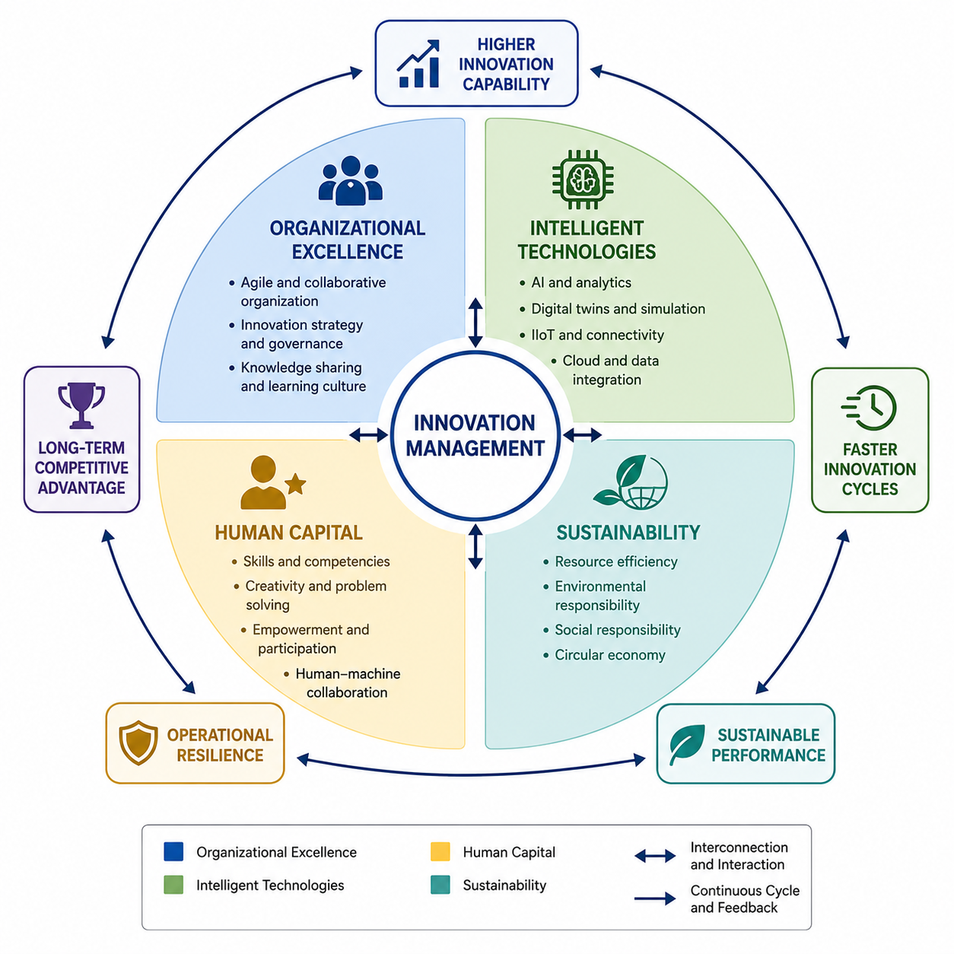
Figure 1 – Integrated Best Practices for Industry 5.0 Innovation Management

Another challenge involves aligning innovation activities with long-term strategic objectives. Organizations often prioritize short-term operational improvements while underestimating investments in organizational learning, knowledge management, and capability development. Consequently, innovation projects may generate isolated technological improvements without producing sustainable competitive advantages.
2. Technological Challenges
The technological complexity of Industry 5.0 environments presents additional obstacles for innovation management. Industrial organizations increasingly rely on interconnected digital technologies, including artificial intelligence, digital twins, Industrial Internet of Things (IIoT), cloud computing, and advanced analytics. Ensuring interoperability among these heterogeneous systems remains a significant technical challenge, particularly in organizations operating with legacy production infrastructures.
Data quality and cybersecurity also represent critical concerns. Effective AI models and digital decision-support systems depend on reliable, consistent, and secure data streams. Inaccurate or incomplete data may lead to suboptimal innovation decisions, while cyber threats targeting industrial information systems can disrupt operations, compromise intellectual property, and reduce stakeholder confidence. Consequently, robust data governance and cybersecurity strategies have become essential components of contemporary innovation management.
3. Human Resource Challenges
Despite rapid advances in intelligent technologies, human capital remains one of the most decisive factors influencing innovation success. Many organizations experience shortages of professionals possessing interdisciplinary competencies that combine engineering knowledge, digital skills, data analytics, and strategic management capabilities. This skills gap limits the effective implementation of advanced innovation technologies and slows organizational transformation.
Employee acceptance of intelligent systems also presents an important challenge. Concerns regarding automation, changing job responsibilities, and the increasing use of artificial intelligence may reduce employee engagement if technological transformation is not accompanied by transparent communication, continuous training, and participatory leadership. Accordingly, innovation management in Industry 5.0 requires organizations to invest not only in technological infrastructure but also in workforce development and organizational culture.
4. Ethical and Regulatory Challenges
The growing integration of artificial intelligence into innovation processes introduces important ethical and regulatory considerations. Organizations must ensure that AI-supported decision-making remains transparent, explainable, and free from unintended bias. Questions related to algorithmic accountability, privacy protection, intellectual property, and responsible use of industrial data have become increasingly significant as AI systems assume greater strategic importance.
Furthermore, sustainability regulations and ESG reporting requirements continue to evolve across global markets. Innovation managers must therefore balance technological advancement with regulatory compliance while ensuring that innovation initiatives contribute to environmental responsibility and social well-being. Successfully navigating these evolving regulatory frameworks requires continuous monitoring of legislative developments together with adaptive governance mechanisms.
To summarize the principal implementation barriers identified in the literature, Table 2 presents the major challenges together with representative mitigation strategies that can support successful Industry 5.0 innovation management.
The challenges discussed in this section demonstrate that successful innovation management extends beyond technological implementation. Long-term competitiveness depends on the ability of organizations to integrate technological capabilities with organizational adaptability, human expertise, and responsible governance. These considerations naturally lead to the question of how innovation management is likely to evolve over the coming years. The following section therefore explores future perspectives and identifies the most important open research questions shaping the next generation of Industry 5.0 innovation management.

Table 2 – Key Challenges and Possible Mitigation Strategies

Challenge Category | Representative Challenges | Possible Mitigation Strategies
Organizational | Resistance to change, fragmented innovation processes, weak strategic alignment | Agile organizational structures, innovation governance, knowledge management, change management programs
Technological | System interoperability, legacy infrastructure, cybersecurity, poor data quality | Standardized digital architectures, secure data governance, interoperable platforms, continuous system integration
Human Resource | Skills shortages, low digital competencies, employee resistance | Continuous training, reskilling initiatives, interdisciplinary teams, participatory leadership
Ethical and Regulatory | AI transparency, data privacy, ESG compliance, intellectual property protection | Responsible AI governance, regulatory monitoring, ethical guidelines, compliance management systems

VI. Future Perspectives and Open Research Questions
The future development of innovation management in Industry 5.0 will be shaped by the increasing integration of intelligent technologies, sustainability-oriented strategies, and human-centered organizational approaches. While current innovation systems already benefit from artificial intelligence, digital twins, and interconnected digital infrastructures, future industrial organizations are expected to evolve toward more adaptive, autonomous, and collaborative innovation ecosystems. This transformation will require new managerial approaches capable of balancing technological autonomy with human creativity, ethical responsibility, and long-term sustainability objectives.
1. Next Generation Intelligent Innovation Systems
Future innovation management systems are expected to become increasingly intelligent, adaptive, and proactive. Instead of responding to technological and market changes after they occur, organizations will increasingly rely on predictive and prescriptive analytics to anticipate future opportunities and risks. AI-supported innovation platforms will enable continuous monitoring of market trends, technological developments, customer requirements, and operational performance, supporting faster identification of innovation opportunities.
The integration of digital twins with artificial intelligence represents another important direction for future innovation systems. Advanced digital twins will evolve from virtual representations of physical assets toward comprehensive innovation environments capable of simulating alternative strategies, evaluating sustainability impacts, and supporting complex managerial decisions. Such systems will enable organizations to experiment with innovative concepts in virtual environments before committing significant physical and financial resources.
2. Autonomous Decision Support and Human–AI Collaboration
A significant future direction involves the development of advanced decision-support systems capable of assisting managers throughout the innovation lifecycle. AI-based systems will increasingly support idea evaluation, technology selection, investment prioritization, risk analysis, and innovation performance assessment. However, future innovation management will not be characterized by fully autonomous decision-making but by effective collaboration between artificial intelligence and human expertise.
Human–AI collaboration represents a fundamental principle of Industry 5.0, where intelligent systems enhance rather than replace human capabilities. Future research should therefore investigate optimal interaction models between managers and AI systems, including methods for improving trust, explainability, transparency, and decision accountability. The development of reliable human-centered AI architectures will be essential for achieving sustainable innovation outcomes.
3. Green and Resilient Industrial Innovation
Sustainability and resilience will become increasingly important dimensions of future innovation management. Industrial organizations will need to develop innovation strategies that simultaneously address climate challenges, resource limitations, supply chain disruptions, and changing regulatory requirements. This transition will accelerate the adoption of green innovation practices, circular business models, renewable energy integration, and resource-efficient production systems.
Future innovation ecosystems will likely incorporate environmental intelligence as a core capability, enabling organizations to evaluate the lifecycle impacts of innovations from early development stages. The combination of digital technologies and sustainability-oriented management approaches will support the creation of resilient industrial systems capable of maintaining competitiveness while reducing environmental impact.
4. Human-Centric Innovation Ecosystems
The future of Industry 5.0 innovation management will increasingly depend on the ability to create environments where humans and intelligent technologies collaborate effectively. Organizations will need to redesign work structures, leadership models, and competency development strategies to support creativity, knowledge sharing, and continuous adaptation.
Human-centric innovation ecosystems will emphasize employee involvement in innovation processes, interdisciplinary cooperation, and lifelong learning. Future industrial competitiveness will therefore depend not only on technological capabilities but also on the ability to develop organizational cultures that encourage experimentation, collaboration, and responsible innovation.
5. Open Research Questions
Despite significant progress in Industry 5.0 innovation management, several research questions remain open:
• How can organizations effectively measure the contribution of human–AI collaboration to innovation performance?
• What governance models are required for responsible AI-supported innovation decisions?
• How can digital twins be expanded from operational optimization tools into strategic innovation platforms?
• Which organizational capabilities are essential for developing resilient and sustainable innovation ecosystems?
• How can innovation management frameworks integrate technological advancement with environmental and social objectives?
Addressing these questions will require interdisciplinary research combining industrial engineering, management science, artificial intelligence, sustainability studies, and organizational behavior. Future innovation management research should move beyond technology adoption models and focus on integrated approaches that explain how technological, human, and organizational capabilities interact to generate sustainable industrial value.
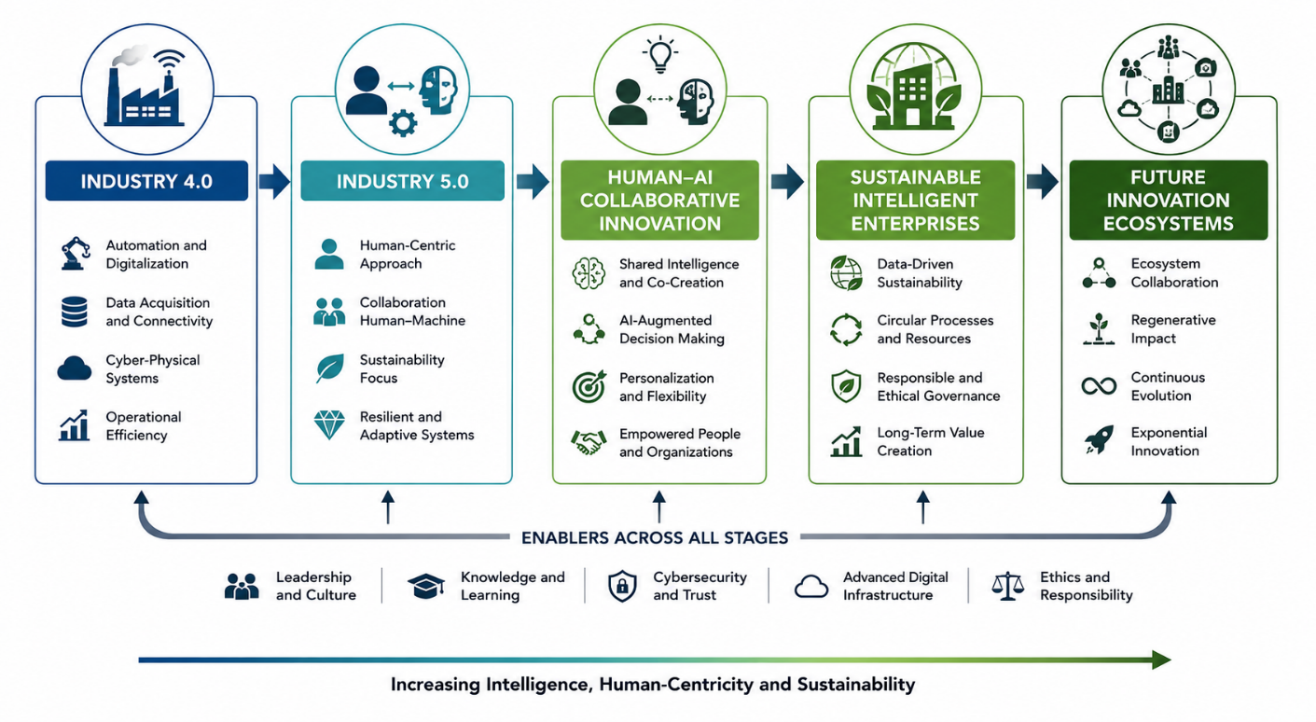
The expected evolution of innovation management toward more intelligent, sustainable, and human-centered systems is summarized in Figure 2.

Figure 2 – Future Evolution of Innovation Management toward Sustainable Intelligent Enterprises

A conceptual evolutionary framework illustrating the transition from Industry 4.0 to future intelligent innovation ecosystems. The model presents five progressive stages: (1) Industry 4.0 – digitalization and automation; (2) Industry 5.0 – human-centric, sustainable, and resilient production; (3) Human–AI collaborative innovation – intelligent decision support and augmented creativity; (4) Sustainable intelligent enterprises – integrated digital, environmental, and organizational intelligence; and (5) Future innovation ecosystems – autonomous, adaptive, and globally connected innovation networks. Arrows indicate continuous evolution driven by technological advancement, sustainability requirements, and human-centered development.
Overall, future perspectives indicate that innovation management will become increasingly complex but also more strategically significant. Organizations capable of integrating intelligent technologies, human capabilities, and sustainability principles will be better positioned to create long-term value in rapidly changing industrial environments.
VII. Conclusions
Industry 5.0 introduces a new stage in the evolution of innovation management by expanding the focus of industrial organizations from technology-driven optimization toward human-centered, sustainable, and resilient innovation systems. The analysis presented in this paper demonstrates that innovation management is undergoing a fundamental transformation in which advanced digital technologies, organizational capabilities, and sustainability objectives become increasingly interconnected.
The study highlights that artificial intelligence, digital twins, Industrial Internet of Things, data-driven analytics, and digital innovation ecosystems are among the most influential factors shaping contemporary innovation practices. However, technological adoption alone is insufficient to ensure successful innovation outcomes. Effective Industry 5.0 innovation management requires the integration of intelligent technologies with human expertise, organizational learning, collaborative structures, and responsible governance approaches.
Current industrial best practices indicate that successful organizations increasingly adopt holistic innovation strategies based on cross-functional collaboration, continuous employee development, open innovation ecosystems, and sustainability-oriented decision-making. At the same time, significant challenges remain, including technological complexity, cybersecurity risks, skills shortages, organizational resistance, and ethical concerns related to artificial intelligence. Addressing these challenges requires coordinated efforts at technological, managerial, and institutional levels.
Future innovation management is expected to evolve toward intelligent and adaptive systems capable of supporting predictive decision-making, virtual experimentation, sustainable transformation, and enhanced human–AI collaboration. The development of such systems will depend on further research into responsible artificial intelligence, digital twin applications, innovation ecosystem governance, and methods for evaluating the combined contribution of technological and human capabilities.
The main contribution of this paper is the synthesis of current trends, industrial practices, implementation challenges, and future perspectives within a unified view of Industry 5.0 innovation management. By emphasizing the interaction between digital intelligence, human creativity, and sustainability principles, the study provides a conceptual foundation for researchers and practitioners seeking to understand and advance innovation management in the next generation of industrial organizations.

Bibliography:
[1] M. Breque, L. De Nul, and A. Petridis, Industry 5.0: Towards a Sustainable, Human-Centric and Resilient European Industry, European Commission, Directorate-General for Research and Innovation, Brussels, Belgium, 2021, doi: 10.2777/308407.
[2] P. K. R. Maddikunta, Q.-V. Pham, B. Prabadevi, N. Deepa, K. Dev, T. Gadekallu, R. Ruby, and M. Liyanage, “Industry 5.0: A survey on enabling technologies and potential applications,” Journal of Industrial Information Integration, vol. 26, 2022, Art. no. 100257.
[3] C. Mourtzis, J. Angelopoulos, and N. Panopoulos, “A literature review of the challenges and future perspectives of Industry 5.0,” Sustainability, vol. 15, no. 6, 2023, Art. no. 4930.
[4] S. Nahavandi, “Industry 5.0—A human-centric solution,” Sustainability, vol. 11, no. 16, 2019, Art. no. 4371.
[5] A. Leng, X. Jiang, and Y. Xu, “Human-centric smart manufacturing in Industry 5.0: Concepts, technologies and challenges,” IEEE Transactions on Industrial Informatics, vol. 19, 2023.
[6] E. Vyhmeister and G. G. Castane, “When Industry meets Trustworthy AI: A Systematic Review of AI for Industry 5.0,” 2024.
[7] P. Fitsilis, P. Tsoutsa, V. Damasiotis, and V. Kyriatzis, “Uncovering Key Trends in Industry 5.0 through Advanced AI Techniques,” 2024.
[8] L. Wang, M. Törngren, and M. Onori, “Current status and advancement of cyber-physical systems in manufacturing,” Journal of Manufacturing Systems, vol. 37, pp. 517–527, 2015.
[9] F. Tao, H. Zhang, A. Liu, and A. Y. C. Nee, “Digital twin in industry: State-of-the-art,” IEEE Transactions on Industrial Informatics, vol. 15, no. 4, pp. 2405–2415, 2019.
[10] F. Tao, M. Zhang, Y. Liu, and A. Y. C. Nee, “Digital twin driven prognostics and health management for complex equipment,” CIRP Annals, vol. 68, no. 1, pp. 169–172, 2019.
[11] S. Ma, K. A. Flanigan, and M. Bergés, “State-of-the-Art Review: The Use of Digital Twins to Support Artificial Intelligence-Guided Predictive Maintenance,” 2024.
[12] Y. Lu, X. Xu, and L. Wang, “Smart manufacturing process and system automation – A critical review of the technologies and challenges,” Journal of Manufacturing Systems, vol. 56, pp. 17–31, 2020.
[13] R. Y. Zhong, X. Xu, E. Klotz, and S. Newman, “Intelligent manufacturing in the context of Industry 4.0: A review,” Engineering, vol. 3, no. 5, pp. 616–630, 2017.
[14] P. Trott, Innovation Management and New Product Development, 7th ed. London, UK: Pearson, 2021.
[15] J. West and M. Bogers, “Leveraging external sources of innovation: A review of research on open innovation,” Journal of Product Innovation Management, vol. 31, no. 4, pp. 814–831, 2014.
[16] H. Chesbrough, Open Innovation: The New Imperative for Creating and Profiting from Technology. Boston, MA, USA: Harvard Business School Press, 2003.
[17] M. Bogers, A. Chesbrough, and C. Moedas, “Open innovation: Research, practices, and policies,” California Management Review, vol. 60, no. 2, pp. 5–16, 2018.
[18] F. Calza, A. Parmentola, and M. Tutore, “Types of innovative activities and innovation performance: The role of knowledge management,” Journal of Knowledge Management, vol. 25, no. 7, pp. 1801–1822, 2021.
[19] A. G. Frank, L. S. Dalenogare, and N. F. Ayala, “Industry 4.0 technologies: Implementation patterns in manufacturing companies,” International Journal of Production Economics, vol. 210, pp. 15–26, 2019.
[20] M. Javaid, A. Haleem, R. P. Singh, and R. Suman, “Artificial intelligence applications for Industry 4.0 and Industry 5.0,” Journal of Industrial Integration and Management, vol. 7, no. 4, pp. 567–602, 2022.
[21] A. Rejeb, K. Rejeb, S. Simske, and H. Treiblmaier, “Digital twin technology in manufacturing: A systematic review,” Computers & Industrial Engineering, vol. 171, 2022, Art. no. 108505.
[22] M. Sony and S. Naik, “Industry 4.0 integration with socio-technical systems theory: A systematic review,” Technological Forecasting and Social Change, vol. 169, 2021, Art. no. 120801.
[23] A. Ivanov, “The Industry 5.0 framework: Human-centricity, sustainability and resilience in industrial transformation,” Technological Forecasting and Social Change, vol. 189, 2023.
[24] M. A. Abdel-Basset, H. Hawash, R. K. Chakrabortty, and M. Ryan, “A comprehensive review of artificial intelligence techniques in Industry 5.0,” IEEE Access, vol. 10, pp. 123456–123480, 2022.
[25] European Commission, Industry 5.0: Research and Innovation Supporting the Sustainable, Human-Centric and Resilient Industry, Brussels, Belgium, 2021.
[26] G. Wickremasinghe, S. Frost, K. Rafferty, and V. Sharma, “Sustainable business decision modelling with blockchain and digital twins: A survey,” 2024.
[27] A. Ivanov, A. Dolgui, and B. Sokolov, “Resilient cyber-physical systems and supply chain management in Industry 5.0,” International Journal of Production Research, 2022.

Assoc. Prof. Eng. Tsanka Marinova Zlateva-Petkova, PhD
Department of Management
Technical University of Gabrovo
4, Hadzhi Dimitar Str.
Gabrovo 5300
Bulgaria
e-mail: tszlateva@abv.bg

