DESIGN AND IMPLEMENTATION OF A REAL-TIME OFDM MODEM USING SOFTWARE-DEFINED RADIO

Ivan P. Ivanov, Ivan I. Ivanov

Abstract: A real-time orthogonal frequency-division multiplexing (OFDM) modem is realized and measured on a general-purpose computer with two software-defined radio platforms. It is built to functional characteristics declared in advance, from which the grid and the frame follow. The OFDM receiver keeps up with the full stream, with no buffer overflow or dropped frame. The declared operating point is met over cable and over the air, and the technical results achieved are close to the theoretical ones.

Key words: OFDM; software-defined radio; synchronization; channel estimation; channel coding

I. INTRODUCTION
Communication and information systems are a fundamental part of the national security system, and radio communication is the part of them that realises mobility — crisis management is where this is felt first [8]. Orthogonal frequency-division multiplexing (OFDM) is the principal modulation of modern wideband radio systems. Its realization by the discrete Fourier transform dates from 1971 [18], and the scheme with its theoretical error bound is set out in the textbook literature [17]. The difficulty lies elsewhere: subcarrier orthogonality is sensitive to timing and frequency offset, so the receiver stages have a literature of their own — frame detection and offset estimation from a preamble [15], [13] — with the complete receive chain in modern form in [16].
OFDM realizations on software-defined radio (SDR) fall into four groups: the early experimental studies of a complete chain in software [12]; the fully functional receivers compliant with an operative standard — IEEE 802.11a/g/p [2], confirmed by extensive measurements in a real channel [3], with multiple-antenna successors [10]; the studies of a single functional block — a preamble-based synchronizer on a radio link [6] or an extension towards spatial multiplexing [11]; and the entire cellular physical layers, srsLTE [5] and OpenAirInterface [9]. A large part of the published results come from simulation or cable, measurements in a real channel are tied to a standard [3] or a single block [6], and the figures rarely carry a traceable origin — conditions, sample size, confidence bound — without which they cannot serve as a reference point.
The contribution of this paper is a single one: an OFDM modem that runs in real time on a general-purpose computer, measured under conditions declared in advance, with sample size and confidence bound; the computational requirements are a measured result, not a design-time assumption.

II. SYSTEM MODEL OF AN OFDM MODEM

A. Software-defined radio and structural block diagram
Software-defined radio, introduced as an architectural principle by Mitola [14], executes the digital processing by a program on a general-purpose device, while the fixed part of the radio is reduced to conversion between analog and digital signal and to translation in frequency [7]. That boundary — computing device against radio-frequency chain — is shown in Fig. 1.
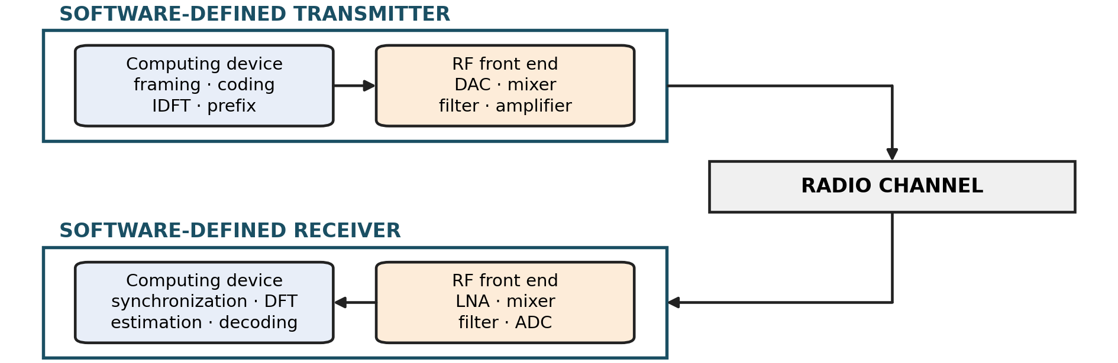
Fig. 1. Structural block diagram of a transceiver with SDR
The consequence: the grid, the frame, the synchronization and the coding are changed without touching the hardware, whereas the bandwidth, the dynamic range and the quality of the local oscillator remain a property of the chain — the limitation at the end of Section V comes precisely from there.

B. Functional block diagram
The chain of the modem — from the source to the recovered bits — is given in Fig. 2. In the transmitter the stream is divided into frames, encoded, the coded bits are interleaved so that adjacent errors do not accumulate within one codeword, and are mapped to modulation symbols; a preamble and pilots are added, the inverse Fourier transform builds the time-domain signal, and the cyclic prefix protects against intersymbol interference.
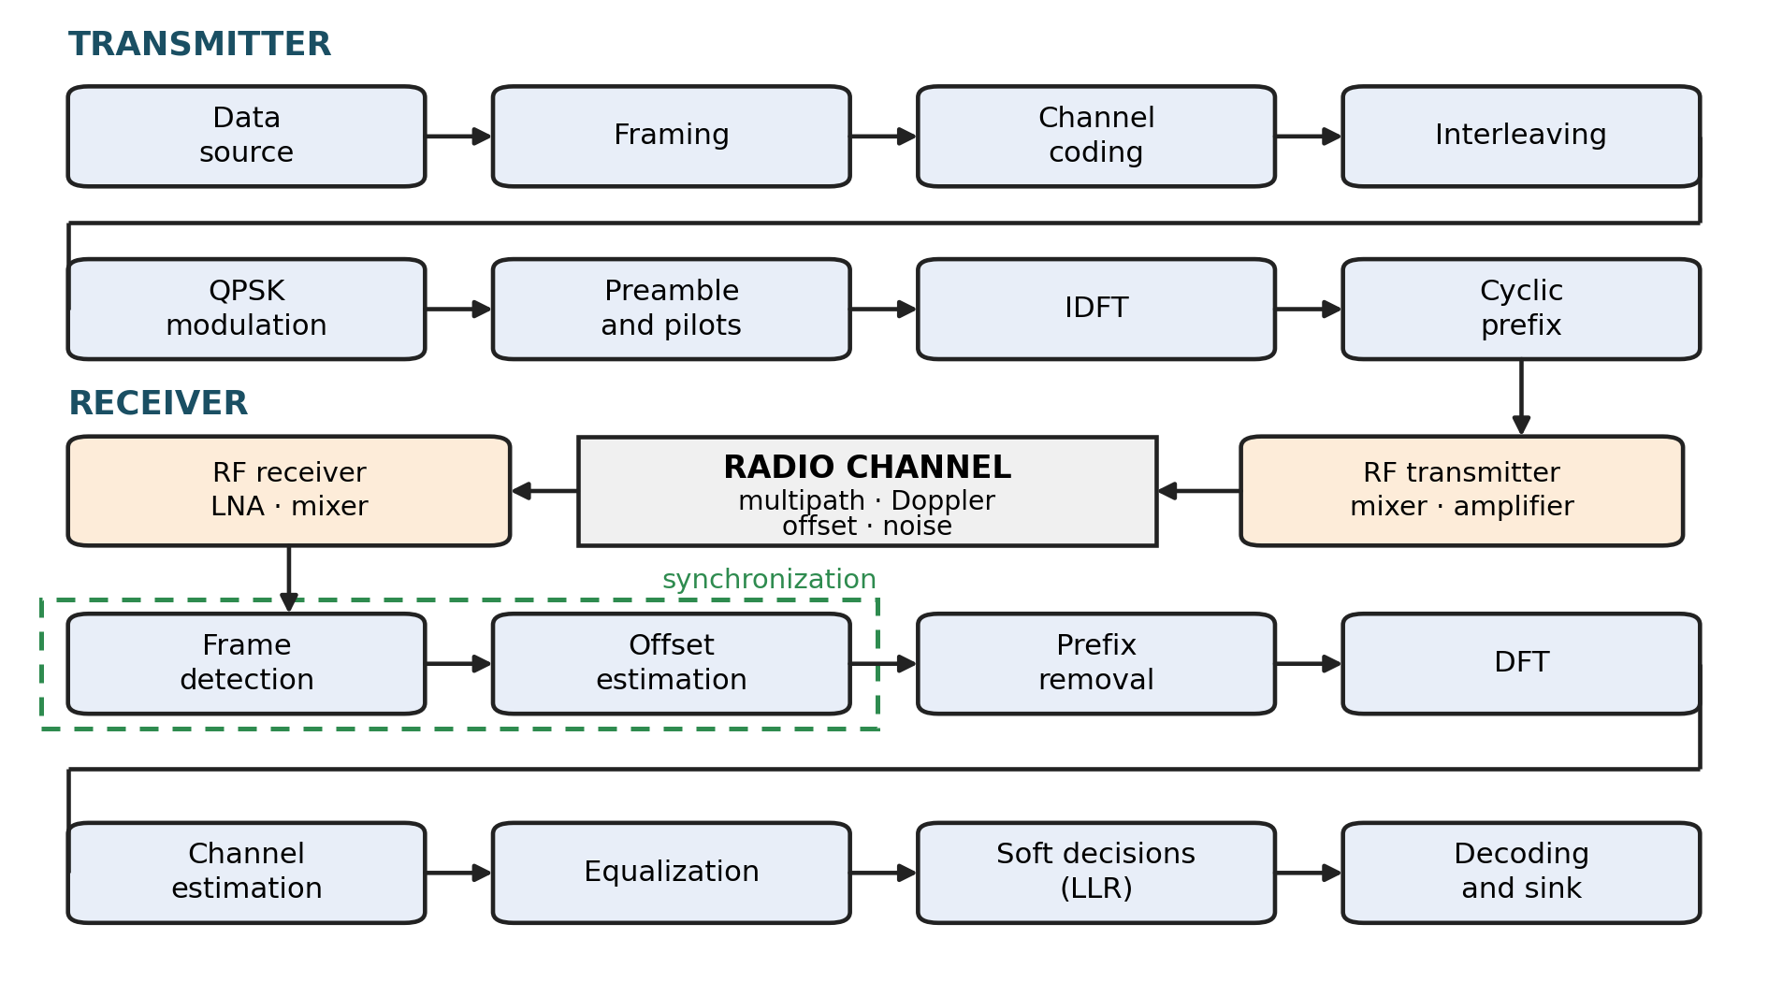
Fig. 2. Functional block diagram of a system with OFDM modulation
In the receiver the processing runs in reverse order, but with one addition: with no external information about arrival, offset or channel, the first two stages are synchronization, and after the Fourier transform the channel is estimated from known symbols and used for equalization.

C. Mathematical description
Let $N$ be the transform size and $X_{l,k}$ the modulation symbol on subcarrier $k$ in symbol $l$. The time-domain signal of the symbol is the inverse discrete Fourier transform
$$s_{l}\left(n\right)=\frac{1}{\sqrt{N}}\sum_{k=0}^{N-1}{X_{l,k}} e^{ j2πkn/N}, n=0,…,N-1.$$ | (1)
Each symbol is preceded by a cyclic prefix — a copy of its last $N_{cp}$ samples — and the transmitted stream $x\left(n\right)$ is the concatenation of the prefixed symbols every $N_{s}=N+N_{cp}$ samples. The channel is a tapped delay line with $L_{h}$ taps,
$$h\left(n,m\right)=\sum_{i=1}^{L_{h}}{a_{i}}\left(n\right) δ\left(m-m_{i}\right),$$ | (2)
where $m_{i}$ are the delays in samples and $∣a_{i}∣^{2}$ follow the power delay profile of an urban macrocell channel with line of sight per [1]: the first tap carries the direct component with Rice factor $K$, while the remaining ones are scattered and Rayleigh-distributed. The dependence on $n$ is slow and is set by the Doppler spectrum with maximum shift $f_{D}=vf_{c}/c$; for stationary platforms the $a_{i}$ are constant within the frame.
The received signal carries a delay $θ$ in samples, a frequency offset $ε$ normalized to the subcarrier spacing, an unknown initial phase $ϕ$, a sampling-clock offset $η$ and additive white Gaussian noise $w\left(n\right)$:
$$r\left(n\right)=e^{ j(2πεn/N+ϕ)}\sum_{m=0}^{L_{h}-1}{h}\left(n,m\right) x\left(\left(1+η\right)n-m-θ\right)+w\left(n\right).$$ | (3)
The four impairments act differently: the initial phase $ϕ$ is common to all subcarriers and is absorbed by the equalization, a delay $θ$ within the prefix gives a phase linear in $k$ and is likewise absorbed, while $ε$ and $η$ are not — the first destroys orthogonality, the second shifts the symbol window with accumulation over the frame.
When $N_{cp}≥L_{h}$ and the offset has been compensated, the discrete Fourier transform over the trimmed symbol gives
$$Y_{l,k}=H_{k} X_{l,k}+W_{l,k},$$ | (4)
where $H_{k}$ is the channel frequency response on subcarrier $k$. Here lies the advantage of OFDM: the frequency-selective channel decomposes into $N$ channels with flat fading, each of which is equalized with a single complex coefficient
$${\hat{X}}_{l,k}=\frac{Y_{l,k}}{{\hat{H}}_{k}}.$$ | (5)
On the equalized sample the decision on the two bits of the quadrature symbol is by the sign of the real and of the imaginary part, and its soft metric is
$$Λ_{l,k}=\frac{2\sqrt{2} ∣{\hat{H}}_{k}∣^{2}}{σ_{w}^{2}} {\hat{X}}_{l,k},$$ | (6)
that is, a log-likelihood ratio for a known channel and Gaussian noise; the factor $∣{\hat{H}}_{k}∣^{2}/σ_{w}^{2}$ weights each subcarrier according to how reliable it is. For quadrature phase-shift keying in additive white Gaussian noise the bit error probability for a known channel is
$$P_{b}=Q​\left(\sqrt{2E_{b}/N_{0}}\right), Q\left(x\right)=\frac{1}{\sqrt{2π}}\int_{x}^{∞}{e^{-t^{2}/2}} dt,$$ | (7)
and this is the curve against which the measurements in Section V are referenced [17].
The channel, however, is not known but estimated from a finite number of observations, and this in itself has a cost. An estimate from $N_{o}$ noisy observations of the same subcarrier carries its own noise with variance $σ_{w}^{2}/N_{o}$; referred to the decision, the loss with respect to a known channel is
$$L_{N_{o}}=10lg​\left(1+\frac{1}{N_{o}}\right) \text{dB}.$$ | (8)
Its application to the fields of the frame is given in Section IV.B.
The cost of the scheme is twofold: the prefix carries no data, so the useful rate falls by the factor $N/\left(N+N_{cp}\right)$, and a residual offset $ε$ destroys orthogonality — it reduces the useful sample by $sinc\left(ε\right)$ and introduces intercarrier interference with power about ${\left(πε\right)}^{2}/3$ of the useful one, growing with the square of the offset. It is therefore synchronization, and not equalization, that sets the lower end of the operating range.

III. DESIGN OF THE MODEM
The design inputs are collected in Table 1; the grid, the frame, the preamble and the cost of decoding are derived from them.
Table 1. Design inputs for the modem
Input | Value
Role | frame transport between two independent nodes
Real time | transmission and reception at stream rate, no post-processing
Numerology | μ = 0 per 5G NR: 15 kHz subcarrier spacing, normal cyclic prefix
Radio channel | urban macrocell with line of sight (UMa LOS) per [1]
Host | general-purpose computer and two SDR platforms
Reference oscillators | independent on the two sides
Receiver | finds the frame in the stream on its own
Coding | one codeword per frame; two codes behind a common interface
Operating point | one percent errored frames at no more than 10 dB per information bit
The profile is a baseline: it serves as a reference point against which more advanced solutions are measured.

A. Grid
The grid coincides with the basic numerology of the fifth generation in subcarrier spacing and in prefix duration, while the transform and the sampling rate are half: the modem remains comparable to an operational system, yet fits into a single computer (Table 2).
Table 2. Grid of the modem
Quantity | Value | Quantity | Value
Sampling rate | 3.84 MS/s | Active subcarriers | 156 (±78, excluding DC)
Transform size | 256 points | Pilot subcarriers | 8, at ±11, ±33, ±55, ±77
Subcarrier spacing | 15 kHz | Data subcarriers | 148
Cyclic prefix | 20 samples (5.21 µs, 7.8 % of the transform) | Occupied bandwidth | 2.34 MHz
Symbol | 276 samples = 71.88 µs | Frame | 28 symbols = 2.013 ms

B. Frame
The structure of the frame is shown in Fig. 3.
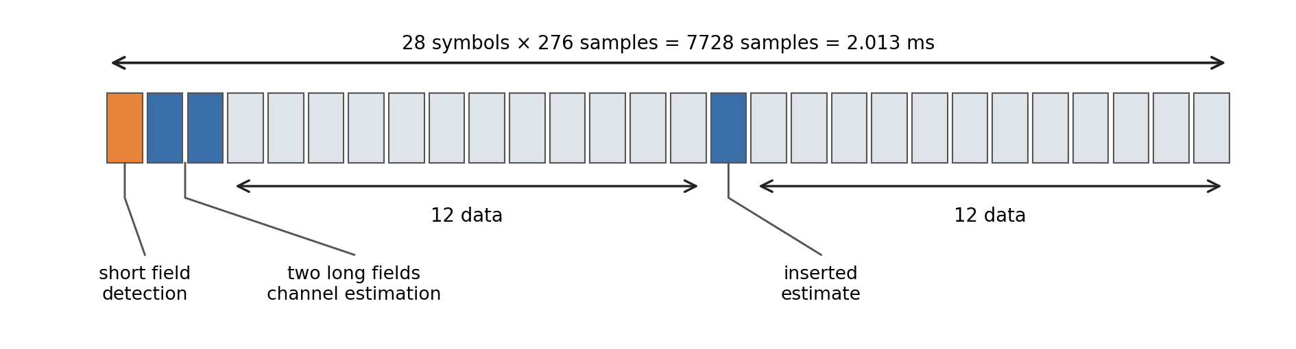
Fig. 3. Structure of the frame
The frame consists of 28 symbols: a short field for detection, two long fields for estimation, twelve data symbols, an inserted symbol for a second channel estimate and another twelve data symbols — 2.013 ms at a payload efficiency of 85.7 %. With $N_{d}$ data subcarriers, $N_{sym}$ data symbols, $\log_{2}M$ bits per modulation symbol and code rate $R_{c}$, the information rate is
$$R=\frac{N_{d} N_{sym} \log_{2}M R_{c}}{T_{frame}},$$ | (9)
that is, $148⋅24⋅2=7104$ modulated bits per frame, a gross rate of 3.530 Mbit/s at 496.9 frames per second and an information rate of 1.762 Mbit/s at an effective code rate of 0.4991. The inserted estimate is not redundancy: with an offset between the reference oscillators a single estimate at the beginning grows stale; its benefit is quantified in Section IV.B.

IV. IMPLEMENTATION

A. Frame detection and synchronization
The short field is built according to the scheme of Minn [13]: every fourth active subcarrier is taken, the time-domain symbol is divided into quarters with signs $[+ + - -]$ and the result is projected back onto the active subcarriers. The detection metric is a normalized correlation of two pairs of quarters at a spacing $q=N/4$:
$$M\left(d\right)=\frac{∣P\left(d\right)∣^{2}}{R{\left(d\right)}^{2}}, P\left(d\right)=S\left(d\right)+S\left(d+2q\right), R\left(d\right)=E\left(d\right)+E\left(d+2q\right),$$ | (10)
where $S$ and $E$ are the correlation and the energy of adjacent quarters. A frame is declared at
$$d^{⋆}=arg\max_{d}M\left(d\right), M\left(d^{⋆}\right)≥M_{min},$$ | (11)
and the two pairs narrow the plateau at the peak to 13 samples against 87 with the halves scheme [15].
The coarse frequency offset follows from the phase of the same sum:
$$Δ{\hat{f}}_{coarse}=\frac{f_{s}}{2πq}argP\left(d^{⋆}\right).$$ | (12)
Since the repetition spacing is $q=N/4$ and not $N/2$, the unambiguous range of the estimate is
$$∣Δf∣<f_{s}/\left(2q\right)=30 \text{kHz},$$ | (13)
that is, two subcarriers — a derived bound, not an assumption, and the measurement in Section V confirms it. The correction is a rotation of the frame before the prefix is stripped:
$$\tilde{r}\left(n\right)=r\left(n\right) e^{-j2π\hat{ε}n/N}.$$ | (14)

B. Channel estimation
The two long fields carry a known binary sequence $X_{k}=±1$; the least-squares estimate over the two symbols is
$${\hat{H}}_{k}^{(A)}=1/2X_{k}\left(Y_{k}^{(1)}+Y_{k}^{(2)}\right),$$ | (15)
while the inserted symbol gives a second, independent estimate ${\hat{H}}_{k}^{(B)}=X_{k}Y_{k}^{(M)}$. By the expression for $L_{N_{o}}$ from Section II.C the first costs 1.76 dB and the second 3.01 dB; their variances are $σ_{w}^{2}/2$ and $σ_{w}^{2}$. For a combination ${\hat{H}}_{k}=α{\hat{H}}_{k}^{(A)}+\left(1-α\right){\hat{H}}_{k}^{(B)}$ the variance is
$$var\left({\hat{H}}_{k}\right)=[{α^{2}}/2+{\left(1-α\right)}^{2}]σ_{w}^{2},$$ | (16)
which is minimized at $α=2/3$ and gives $σ_{w}^{2}/3$:
$${\hat{H}}_{k}=2/3{\hat{H}}_{k}^{(A)}+1/3{\hat{H}}_{k}^{(B)}.$$ | (17)
The loss becomes 1.25 dB — less than either of the two taken separately; the measured value is 1.26 dB. The combination is an addition to the receiver and is not exercised in the runs of Section IV, where each half uses its own estimate. The common phase is tracked by the eight pilot subcarriers in every symbol.

C. Channel coding and soft decisions
One frame carries exactly one codeword. The two codes stand behind a common programming interface and are interchanged without any change in the rest of the chain: a terminated convolutional code with $K=7$ and polynomials (133,171)₈ at rate 1/2, and the downlink traffic code of the fifth-generation specification [4] — a low-density parity-check (LDPC) code, base graph 2, $Z=384$, at rate 0.4991. Both carry the 3546 information bits of a frame into its 7104 coded bits.
The soft decisions are formed by the expression for $Λ_{l,k}$ from Section II.C. The scale matters: the belief-propagation decoder clips the values from above, and clipping without prior normalization makes the error curve non-monotonic at a high signal-to-noise ratio; the block is therefore normalized by the mean magnitude.

D. Decoding as a question of throughput
The receive path must fit within the frame window of 2.013 ms; for the decoding this does not hold, and, the frames being independent, it is entrusted to a pool of $P$ threads. The requirement is then not on latency but on throughput — the time for one frame $T_{dec}$ may exceed the frame period, provided that
$$\frac{P}{T_{dec}} ≥ \frac{1}{T_{frame}}, \text{that is,} T_{dec}≤P T_{frame}.$$ | (18)
The difference between the two requirements is shown quantitatively in Section V.

V. EXPERIMENTAL SETUP AND RESULTS OBTAINED
The host is a computer with eight cores and sixteen threads (AMD Ryzen AI 7 PRO 350), transmission and reception running as two processes pinned to separate cores, with two USRP B210 platforms with independent reference oscillators, at a carrier of 3.32 GHz and 3.84 MS/s. The cable setup connects them through a coaxial chain with an attenuator, the over-the-air setup through antennas at a short distance with a fixed receiver gain of 50 dB; in both, the operating point is varied by the transmitter gain. What was measured is given in Fig. 4.
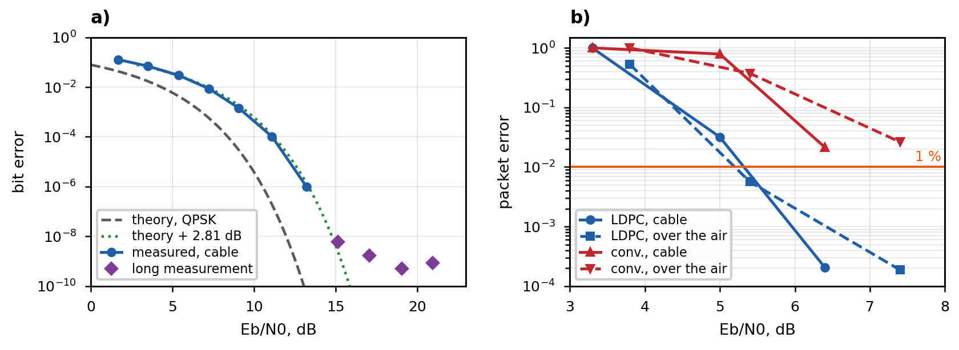
Fig. 4. Uncoded bit error over cable against the theoretical QPSK curve (a) and packet error of the two codes over cable and over the air (b)
The measured curve in Fig. 4a runs parallel to the theoretical curve for quadrature phase-shift keying in additive white Gaussian noise [17] at a constant gap of 2.81 dB — a loss in signal-to-noise ratio, not a defect that accumulates — and the gap is accounted for in full.
Estimation from the two long fields costs 1.67 dB in the first half of the frame, and from the inserted symbol 2.89 dB in the second, while the measured gap over the whole frame is 2.44 dB; 0.37 dB remains for the radio-frequency part, part of which may be due to attenuation along the cable chain. The first two figures follow from the expression for $L_{N_{o}}$ and agree with the measurements to within 0.15 dB. The timing position and the frequency offset do not contribute to the loss: over 300 frames all were found at the exact position.
Above 15 dB the curve departs from the theoretical one and reaches an error floor of 6.7·10⁻¹⁰ (confidence interval 4.3·10⁻¹⁰ – 9.9·10⁻¹⁰, from 24 errors in 36 billion bits). The cause has not been established, but it is not the transmitter: the quality of the modulation vector improves monotonically up to the highest gain.
Coding changes the picture (Fig. 4b). The packet error rate crosses one percent at 6.73 dB over cable and around 6.9 dB over the air for the convolutional code, and at 5.37 dB over cable and around 5.3 dB over the air for LDPC: cable and air coincide to within one or two tenths of a decibel over two completely different chains, which makes the cable figures representative. Through the actual chain the difference between the codes is 1.36–1.6 dB, because the loss weighs equally on both.
At the operating point around 9 dB not a single frame was in error: 0 of 87,938 frames over cable at 9.11–9.45 dB and 0 of 145,771 over the air at 8.41–9.38 dB. With zero observed events a point estimate is meaningless, so what is given is the exact upper bound of a one-sided 95-percent confidence interval: 3.41·10⁻⁵ over cable and 2.06·10⁻⁵ over the air.
The computational requirements are measured on the operating receiver at full stream rate, and not from a design-time estimate; what was measured is in Table 3.
Table 3. Cost of decoding at 496.9 frames per second
Decoder | Per frame, mean | 95th percentile | Cores out of 16
Convolutional (Viterbi) | 1.717 ms | 2.066 ms | 0.85
LDPC per TS 38.212 | 3.505 ms | 4.713 ms | 1.74
The figures separate the two requirements: in latency both decoders exceed the 2.013 ms window, so a single-threaded coded receiver would fall behind, while in throughput the heaviest case requires under two of sixteen threads. This is precisely why decoding was moved to a pool; the remainder of the receive path fits within the window on a single thread.
Real time is not a conclusion drawn from these figures, but the condition under which all the others were obtained: transmitter and receiver run simultaneously on one computer at 496.9 frames per second, and in the two acceptance setups — 233,709 frames in total — there was not a single buffer overflow, stream interruption or frame dropped by the pool.
Robustness was swept impairment by impairment: a frequency offset of ±30 kHz on the actual units, in agreement with the derived bound; a sampling-clock offset of 0.172 ppm, agreeing with the carrier offset to three digits — a single reference oscillator feeds both; a Doppler shift of 154 Hz and the channel declared in Table 1, against recorded realizations at 10 dB. Outside the range the modem does not perform worse, it stops receiving: the coarse estimate wraps and the confirmation by the long field refuses. The lower end of the curves is limited by detection, not by the code: between 3 and 4.5 dB over the air the fraction of accepted frames falls from 97 to 73 %, while the code has already done its work.
Finally, the influence of the radio-frequency front end. Local-oscillator leakage in a direct-conversion receiver is a known shortcoming of it [7]: the uncoded curve initially passed into a linear segment above 10 dB — a shape incompatible with additive Gaussian noise — sourced in leakage into subcarriers ±1 and ±2. The remedy is structural, not algorithmic: the local oscillator is offset from the carrier by 1.545 MHz, so that the leakage falls in an unoccupied part of the spectrum with the analog bandwidth unchanged. Simulation does not reveal such a limit, because it is not a property of the processing.

VI. CONCLUSION
An OFDM modem with quadrature phase-shift keying has been designed and implemented that runs in real time on a general-purpose computer with two software-defined radio platforms, with channel coding per the fifth-generation specification [4]. Real time is demonstrated, not asserted: the receiver runs at stream rate without a single overflow or dropped frame, at a load of a small fraction of the host. The declared operating point is met both over cable and over the air, and the gap from theory is constant and accounted for in full, dominated by the cost of channel estimation.

ACKNOWLEDGMENTS
This work was supported by the National Scientific Program Security and Defense, funded by the Ministry of Education and Science of the Republic of Bulgaria under grant agreement no. D01-74/19.05.2022.

REFERENCES
1. 3GPP TR 38.901 V16.1.0. Study on channel model for frequencies from 0.5 to 100 GHz. 3GPP, 2020.
2. Bloessl, B., et al. An IEEE 802.11a/g/p OFDM Receiver for GNU Radio. In: Proc. ACM SIGCOMM Workshop on Software Radio Implementation Forum, 2013, pp. 9–16.
3. Bloessl, B., et al. Performance Assessment of IEEE 802.11p with an Open Source SDR-Based Prototype. IEEE Transactions on Mobile Computing, 2018, vol. 17, no. 5, pp. 1162–1175.
4. ETSI TS 138 212 V18.5.0. 5G; NR; Multiplexing and channel coding. ETSI, 2024.
5. Gomez-Miguelez, I., et al. srsLTE: An Open-Source Platform for LTE Evolution and Experimentation. In: Proc. ACM WiNTECH, 2016, pp. 25–32.
6. Herrera-Bustamante, J., et al. Design and Implementation in USRP of a Preamble-Based Synchronizer for OFDM Systems. In: Proc. IEEE ANDESCON, 2020, pp. 1–6.
7. Ivanov, I. P. Software-Defined Radio Communication Systems. Sofia: “Prof. Tsvetan Lazarov” Defence Institute, 2025. ISBN 978-619-90024-8-3. (in Bulgarian)
8. Ivanov, V., A. Manchev. Crises and Some Possibilities for Their Successful Management. In: Proc. International Scientific Conference “Contemporary Research and Technologies for Defence ARTDEF 2021”, Naval Academy “Nikola Yonkov Vaptsarov”, Varna, 2021, pp. I-86–I-93. ISSN 2815-2581. (in Bulgarian)
9. Kaltenberger, F., et al. OpenAirInterface: Democratizing Innovation in the 5G Era. Computer Networks, 2020, vol. 176, art. 107284.
10. Lin, N., et al. GR-WiFi: A GNU Radio Based WiFi Platform with Single-User and Multi-User MIMO Capability. Physical Communication, 2025, vol. 72, art. 102812.
11. Martelli, F., et al. MIMO-OFDM Spatial Multiplexing Technique Implementation for GNU Radio. In: Proc. ACM SIGCOMM Workshop on Software Radio Implementation Forum, 2014, pp. 1–12.
12. Marwanto, A., et al. Experimental Study of OFDM Implementation Utilizing GNU Radio and USRP-SDR. In: Proc. IEEE MICC, 2009, pp. 132–135.
13. Minn, H., M. Zeng, V. K. Bhargava. On Timing Offset Estimation for OFDM Systems. IEEE Communications Letters, 2000, vol. 4, no. 7, pp. 242–244.
14. Mitola, J. The Software Radio Architecture. IEEE Communications Magazine, 1995, vol. 33, no. 5, pp. 26–38.
15. Schmidl, T. M., D. C. Cox. Robust Frequency and Timing Synchronization for OFDM. IEEE Transactions on Communications, 1997, vol. 45, no. 12, pp. 1613–1621.
16. Schwarzinger, A. Digital Signal Processing in Modern Communication Systems. Ed. 2.0, 2021. ISBN 978-0-9888735-1-3.
17. Sklar, B., F. Harris. Digital Communications: Fundamentals and Applications. 3rd ed. Pearson Education, 2021.
18. Weinstein, S. B., P. M. Ebert. Data Transmission by Frequency-Division Multiplexing Using the Discrete Fourier Transform. IEEE Transactions on Communication Technology, 1971, vol. 19, no. 5, pp. 628–634.

COL (Ret.) Assoc. Prof. Eng. Ivan Penchev Ivanov, PhD
Defence Institute “Prof. Tsvetan Lazarov”
Sofia, 1592, 2 Professor Tsvetan Lazarov Blvd, Bulgaria
tel.: +359 2 9221822
e-mail: i.p.ivanov@di.mod.bg

Lt. Col. Eng. Ivan Iliev Ivanov
Joint Forces Command
Sofia, 1606, 34 Eduard Totleben Blvd, Bulgaria
e-mail: i.i.ivanov@armf.bg

